

(Palai, 2007)

**Design Report**

Website Design & Implementation

Introduction to Web Design (DECO1400) Semester 1, 2019

**By Harry Huang (45309151)**

**Table of Contents**

Introduction 4

**Introduce Yourself** 4

Getting to Know Stakeholders 5

**Target Audience** 5

**Chosen Educational Content** 9

**Chosen Story** 9

Navigation & Organisation 10

**Card Sorting** 10

**Navigation Systems** 13

**Site Map** 15

**Visual Organisation** 17

**Interactivity & Functionality** 19

**Paper Prototyping** 23

Aesthetics 27

**Style Guide** 27

**Aesthetics User Testing** 30

Website Implementation 34

**Accessibility, Graceful Degradation & Progressive Enhancement** 34

**Security & Privacy** 38

**Hi-Fi User Testing** 42

Conclusion 45

**Course Reflection** 45

References 46

**Part A**

Introduction

This Design Report is for the client (Course coordinator, Matt and Tutors, Steven and Kathryn) of which I’m making my website for.

Detailed information outlining the specifications of the website can be expected from the following pages of the report.

# **Introduce Yourself**

My full legal name is Juhua Huang, but you can call me Harry. I am a quiet person by nature, but I love to do lots of fun things. My hobbies are: watching TV, playing sports and hanging out with family and friends.

I’m originally from China, but I moved to Australia when I was 7 years old and have been living in Australia for over 10 years (so I guess you could pretty much call me an Aussie). I went to school on the Gold Coast and moved up to Brisbane for uni. I current reside at Union College within UQ.

I am currently in my second year of Engineering (Honours) majoring in Software. The experience I’ve had with web design would be making a website in Dreamweaver in high school; other than that, I haven’t had much other experience with web design in terms of using HTML, CSS, JavaScript and jQuery. I have had programming experience in the form of Python and I’m currently studying Java and C. My future goals/ interests would be to get into software development, in terms of creating apps, websites, etc. which could create positive change towards society.

My learning strategy would to be turn up to every class and give my best in every task. In terms of course work and assessment, I would make sure that I am on top of them; this means starting early and leaving plenty of time for consultation and feedback.

Getting to Know Stakeholders

# **Target Audience**

The specific target audience of my website are Year 7 to 9 students (i.e. 12 to 14-year-olds).

The tables in the pages below describe three personas that represent different, archetypal users of my website.

The common traits identified from my personas is that the primary users are all smart kids who want to head into the field of Science in the future. The secondary user identified would usually be teachers who are scouting whether the website is appropriate for their students.

The implication that the target audience has on the design means that the website must be interactive so the user can have a good time learning on the website. Website must simple to navigate through the use of a good Navigation System. This website should also balance text and images so the user can easily find what they want. Furthermore, the content on the website should be meaningful and not too simple, so the user can get the knowledge they want out of it.

Persona 1, Primary User:

|  |  |
| --- | --- |
| **Basic details** | Name: Xavier, Age: 13, Gender: Male, Occupation: Year 8 student.  (Mars, 2019) |
| **Bio** | Xavier is a bright and respectful young man who is attending high school on the Gold Coast. Xavier is very interested in Chemistry and is keen to further his studies at university. However, there are areas that Xavier can work on, for example, increasing his motivation for research and writing reports as this is a huge part of Science. |
| **Goals** | * Graduate high school with Op1 to 5 * Get into Chemical Engineering at UQ * Work for a large company upon graduation |
| **Frustrations** | * Internet research * Writing reports * Asking the teacher for help |
| **Use of website** | * Learn about the periodic table * Learn about interesting chemical reactions * Starting point for research assignment |

Persona 2, Primary User:

|  |  |
| --- | --- |
| **Basic details** | Name: Molly, Age: 13, Gender: Female, Occupation: Year 8 student.  (freestocks.org, 2018) |
| **Bio** | Molly is a young girl with big dreams. She is smart and currently top of her Science class. Molly hopes to study Science after high school and eventually get into research. |
| **Goals** | * Get 90%+ in Science exam * Do scientific research after uni * Work for CSIRO one day |
| **Frustrations** | * Non-Science related subjects, i.e. the Humanities * Websites with too much text and hard to navigate * Wasting time doing work that is unnecessary |
| **Use of website** | * Pre-reading that the teacher set to do * Learn about extra content beyond scope of Year 8 Science * Alternative to looking up facts on Wikipedia, as this website if more fun and interactive |

Persona 3, Secondary User:

|  |  |
| --- | --- |
| **Basic details** | Name: Patrick, Age: 45, Gender: Male, Occupation: Year 8 Science Teacher.  (Moose Photos, 2018) |
| **Bio** | Patrick is a middle-aged man and a Year 8 Science teacher. Patrick has been teaching for over 10 years and loves to educate and inspire the next generation to work hard and make a positive change to the world. Although Patrick seem to be a Science geek, he loves to go on adventures on the weekend riding his motorbike. |
| **Goals** | * Teach senior Chemistry (Year 11 and 12) within the next year or two * Have at least one of his students achieve an OP1 upon graduation * Find a long-term partner by the end of the year |
| **Frustrations** | * When students don’t follow his instructions * When students ask simple questions without reading the task properly themselves |
| **Use of website** | * See if website is suitable for a pre reading starting point for his Year 8 Science class * Check whether website has appropriate content |

# **Chosen Educational Content**

My chose education content is basic High School Chemistry. All of the content on my website will be taken from the Jacaranda Science Quest 7-10 Australian Curriculum textbooks written by (Wiley, 2018).

This educational content is an interesting choice for my target audience, as it is compulsory for Year 7 to 9 students to study Science (Highschool Australia, 2019). Learning about the basics of Chemistry in a fun way on my website would increase the chance of early high school students to stick with Chemistry in senior years, and possibly get into Science and others relating fields in further studies.

# **Chosen Story**

My chosen story is Harry Potter in the genre of fantasy fiction.

Harry Potter is an interesting choice for my website in relation to my target audience, as it is a prime text for 12 to 14 years to read. The idea of magic, potions, etc. can provide a fun and interactive theme for the website in terms of teaching the target audience about the chosen educational content of basic Chemistry. The idea of Harry Potter would also provide many awesome visuals which would make a fun interactive learning experience for the user.

Navigation & Organisation

# **Card Sorting**

Reflecting on the card sorting design activity, it was successful, as the testing plan was executed without problems, and quality feedback was received.

Testing plan for card sorting:

1.

|  |  |
| --- | --- |
| **Content (nouns):** | **Actions (verbs):** |
| Separating mixtures | Removing salt from a pot of ‘stuff’ |
| Elements, compounds and mixtures | Looking at the periodic table |
| Chemical change | Doing experiments involving chemical change |
| Inside the atom | Drawing an atom’s protons, neutrons and electrons |
| Chemical reactions | Writing and balancing chemical equations |

2. Each key word/ topic will be written on paper cards, so the user can arrange them into order.

3. A closed card sort will be performed with the user placing cards into pre-defined groups. An open card sort may be considered for cards which don’t fit into pre-defined groups.

4. From Observations of the card-sort, questions will be asked of the user about possible content structure suggestions, along with their experience of the card-sorting. These factors will be taken into consideration when building the website’s navigation system and visual organisation.

Photos card sorting activity:

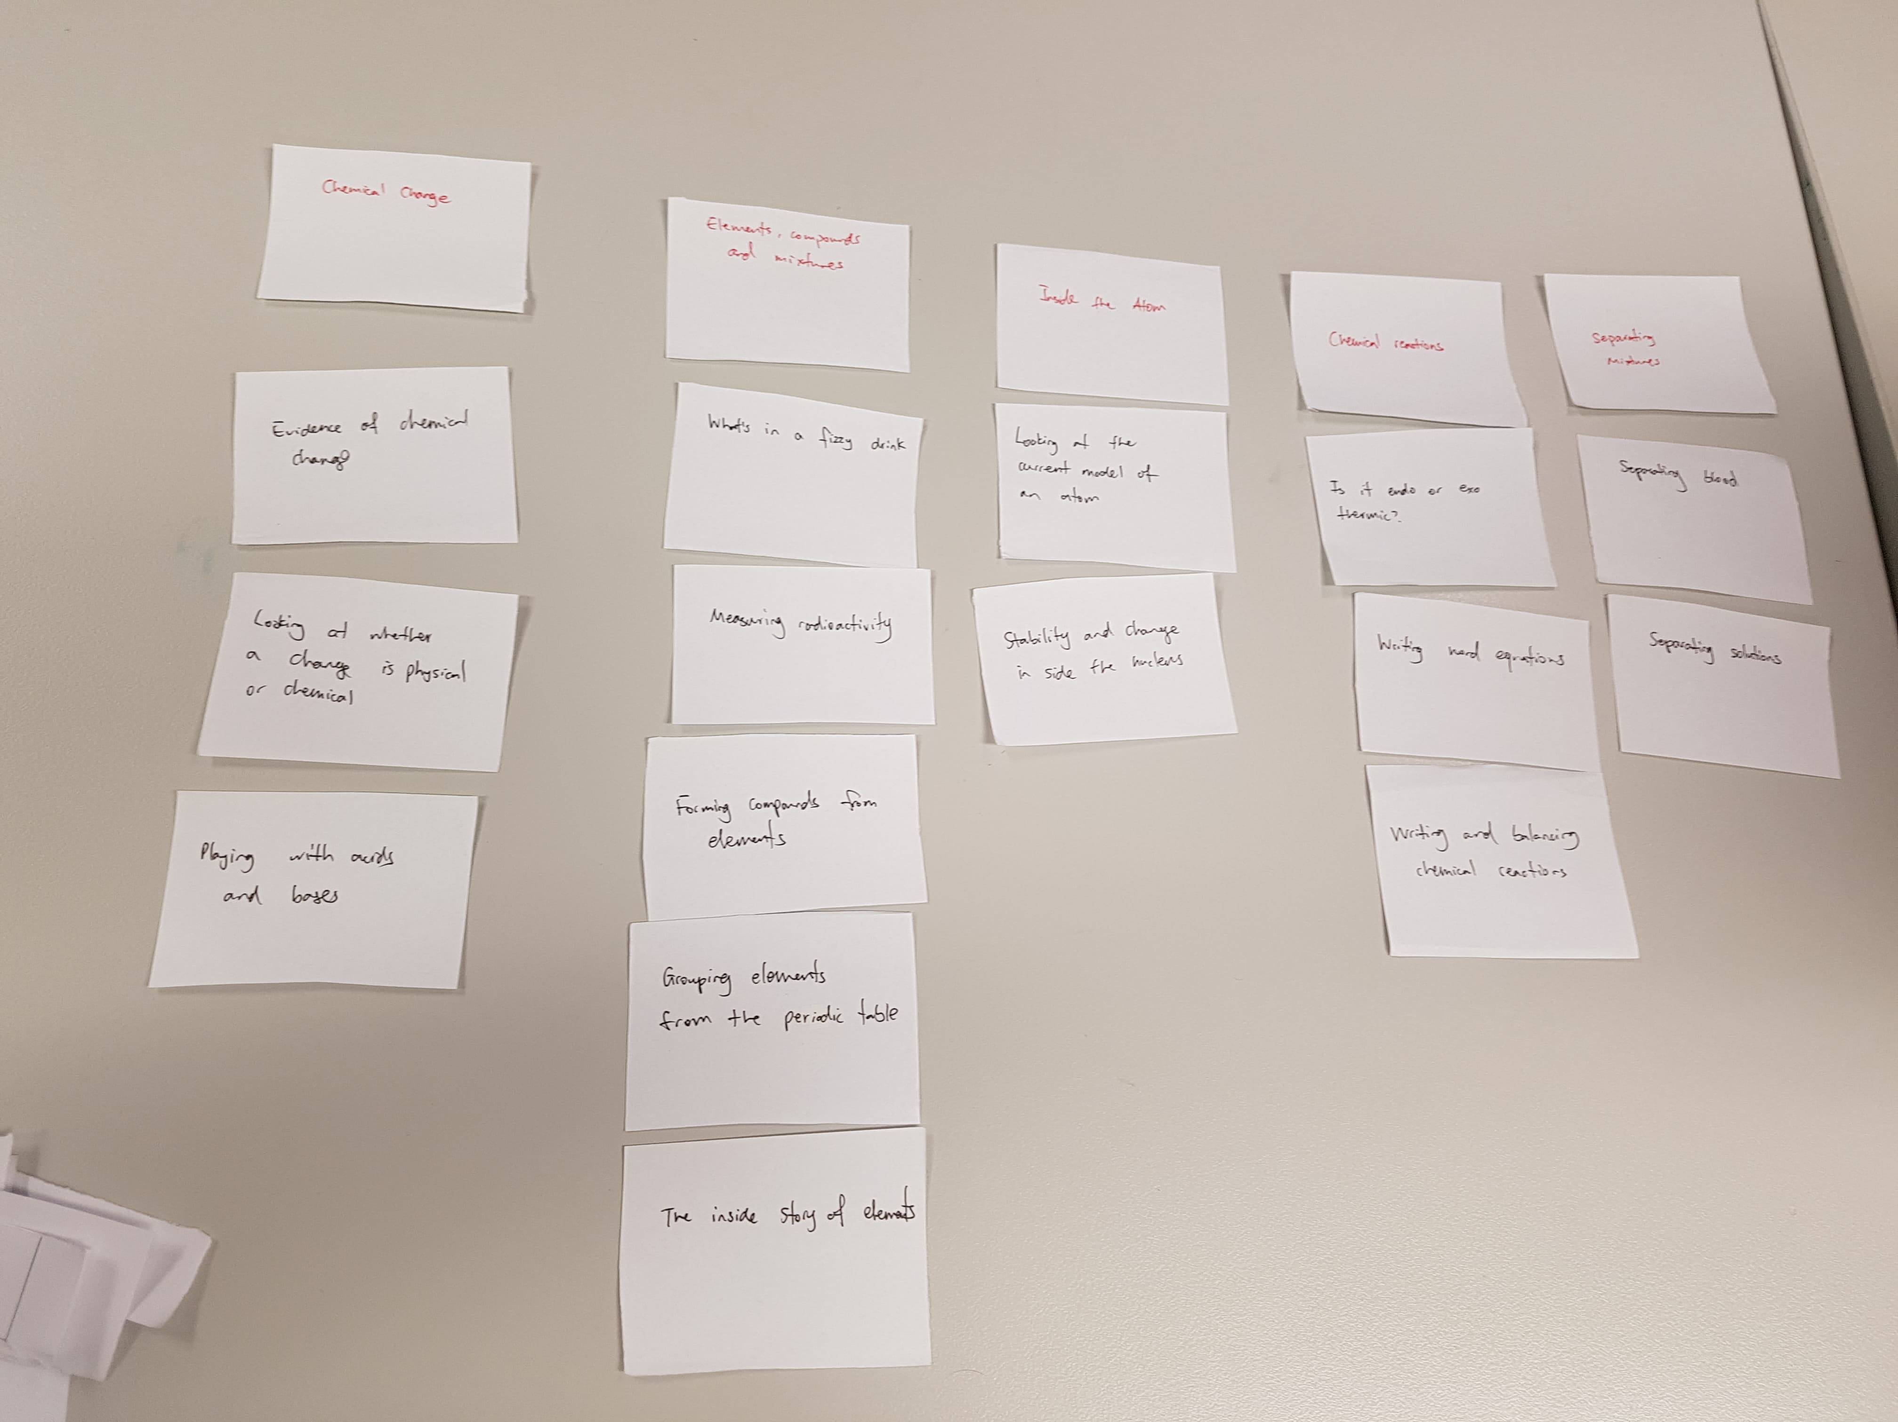

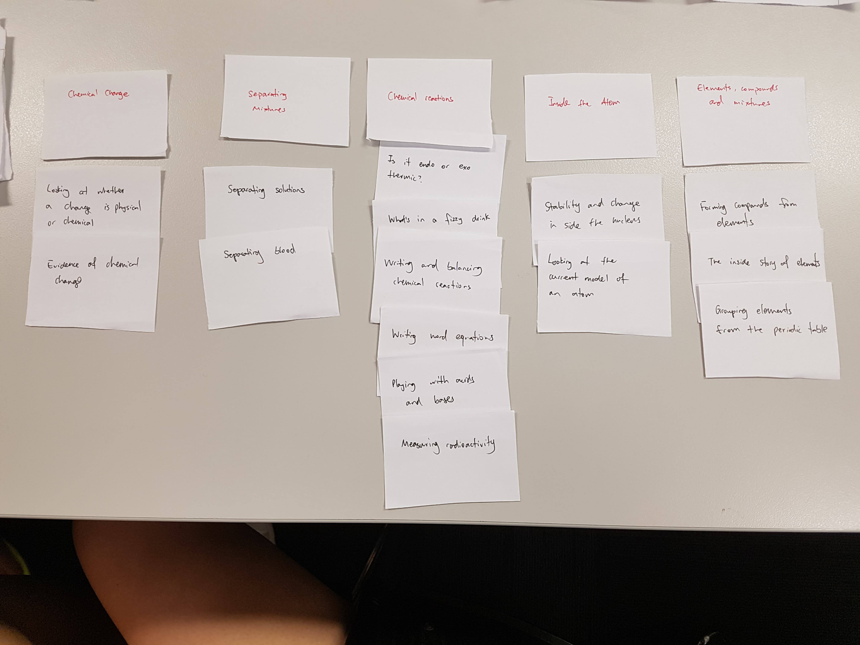

The card-sorting activity was done with 2 different individuals, and it appeared that these individuals both had different ideas of which cards go under which pre-define topics. It was suggested that for the website, overlapping content should be combined into one.

The feedback from this activity has allowed me to do preliminary planning for my website, where a navigation menu will be included with all the main topics under it. Each topic will then have one page with all its content inside it. In the navigation menu, under each topic, there will be content buttons directing the user to a specific part of a webpage where their desired content is. The website should be organised well with good layout, balance and patterns.

# **Navigation Systems**

The key things learnt from Navigation Systems group discussion:

* A website with good navigation systems should essential have clear buttons/links for the users to press taking them to the content of the website that they want to see.
* It is bad to have a website which has too many things going at once, where the user is turned off as they are unsure of what to click to go where.

Using the IKEA website, I could tell it had a good navigation system as it had simple buttons telling me what to click if I wanted to perform a particular task. So, for example, if I wanted to buy a chair from Ikea, I could easily do that. On the arngren.net website, buying an item wasn’t so easy. After navigating through multiple clustered pages, I was taken to a form which I had to fill out and email back to the company to finalise my order. The frustration I got from that was a strong indication that a bad navigation system was present.

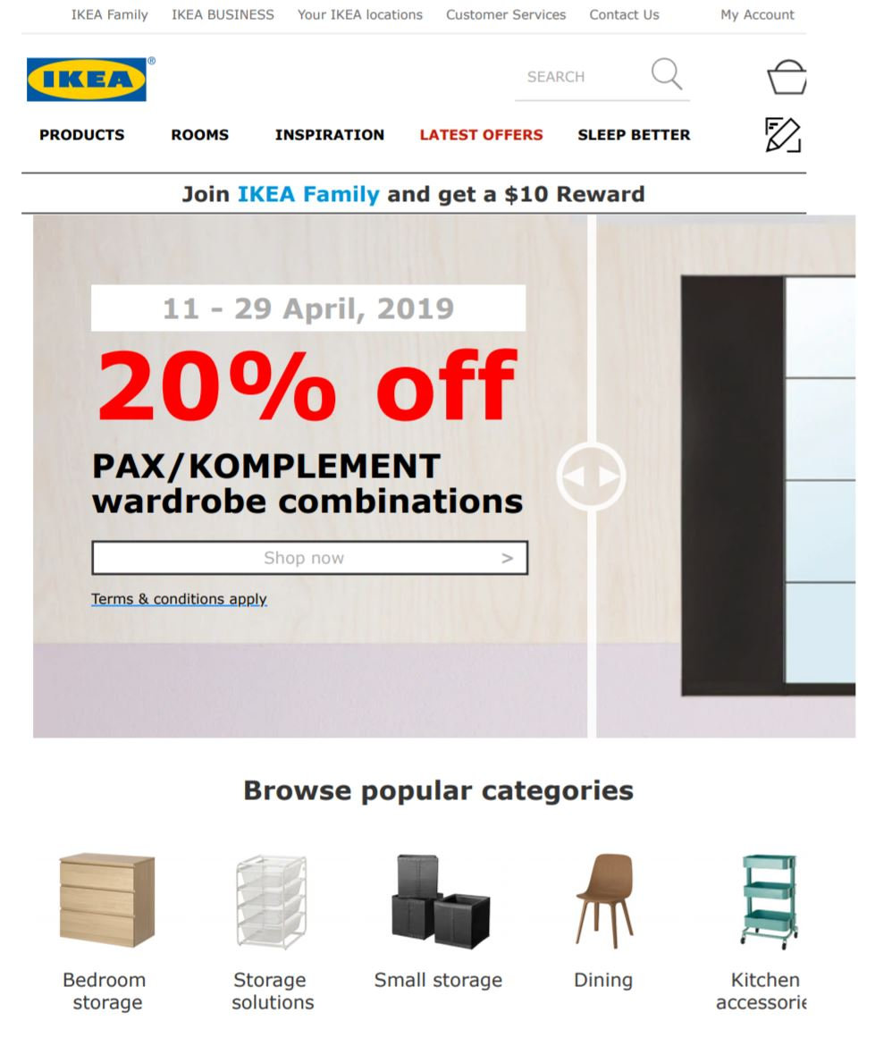

(IKEA, 2019)

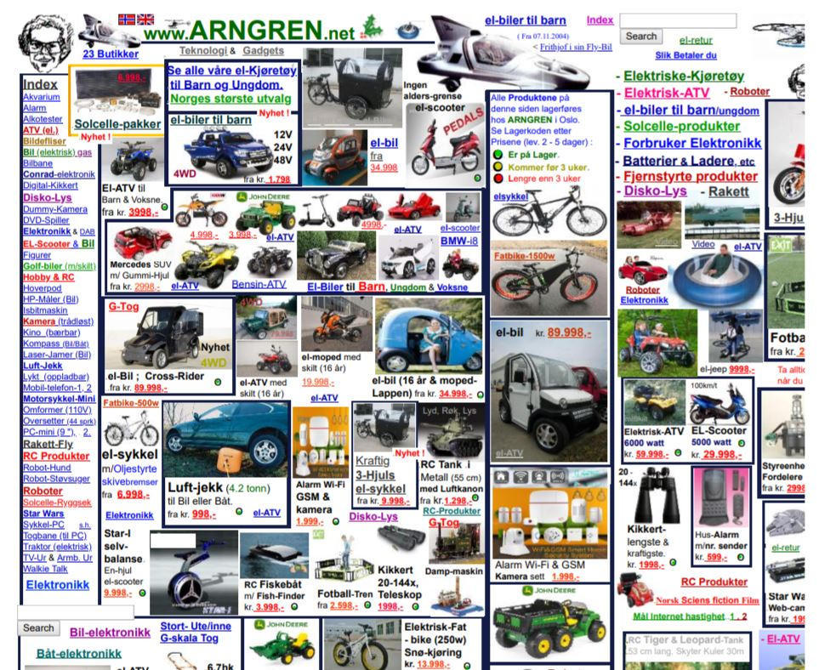

(arngren.net, 2004)

In my website, a top and side navigation bar will most likely be used. The top bar will show the main topics collect from the card-sorting activity with drop-downs of sub-headings and content. When the user goes to a specific content page, the top bar will still exist if they wanted to go to another page. Furthermore, a side bar will appear throughout the page allowing the user to be taken to a specific part of the page without having the scroll down. These are quite simple examples of primary, secondary navigation being implemented to provide an easy-to-use website for the user. Other forms such as utility, footer and global navigation will also be considered for ease-of-access.

# **Site Map**

Site map that visualises the navigation flow of my website:

* The home page can be accessed from every page on the website by clicking anywhere on the header (global navigation), e.g. logo.
* Specific topic pages can be accessed from every page by clicking on the specific buttons in the top primary navigation menu.
* Content specific sections under topic pages can be accessed by either scroll down the topic page or clicking on the buttons in the auto-hide side menu bar (secondary navigation).
* The administrative pages, i.e. ‘Contact Us’, ‘Acknowledgements’, etc. can be accessed from every page by clicking on their specific links in the footer (footer navigation).

Storyboard how a persona will navigate my website:

1. Molly is in her Year 8 Science class and her teacher tells the class to go onto ‘Harry’s Lab’ to learn about the basic model of an atom before he starts teaching.

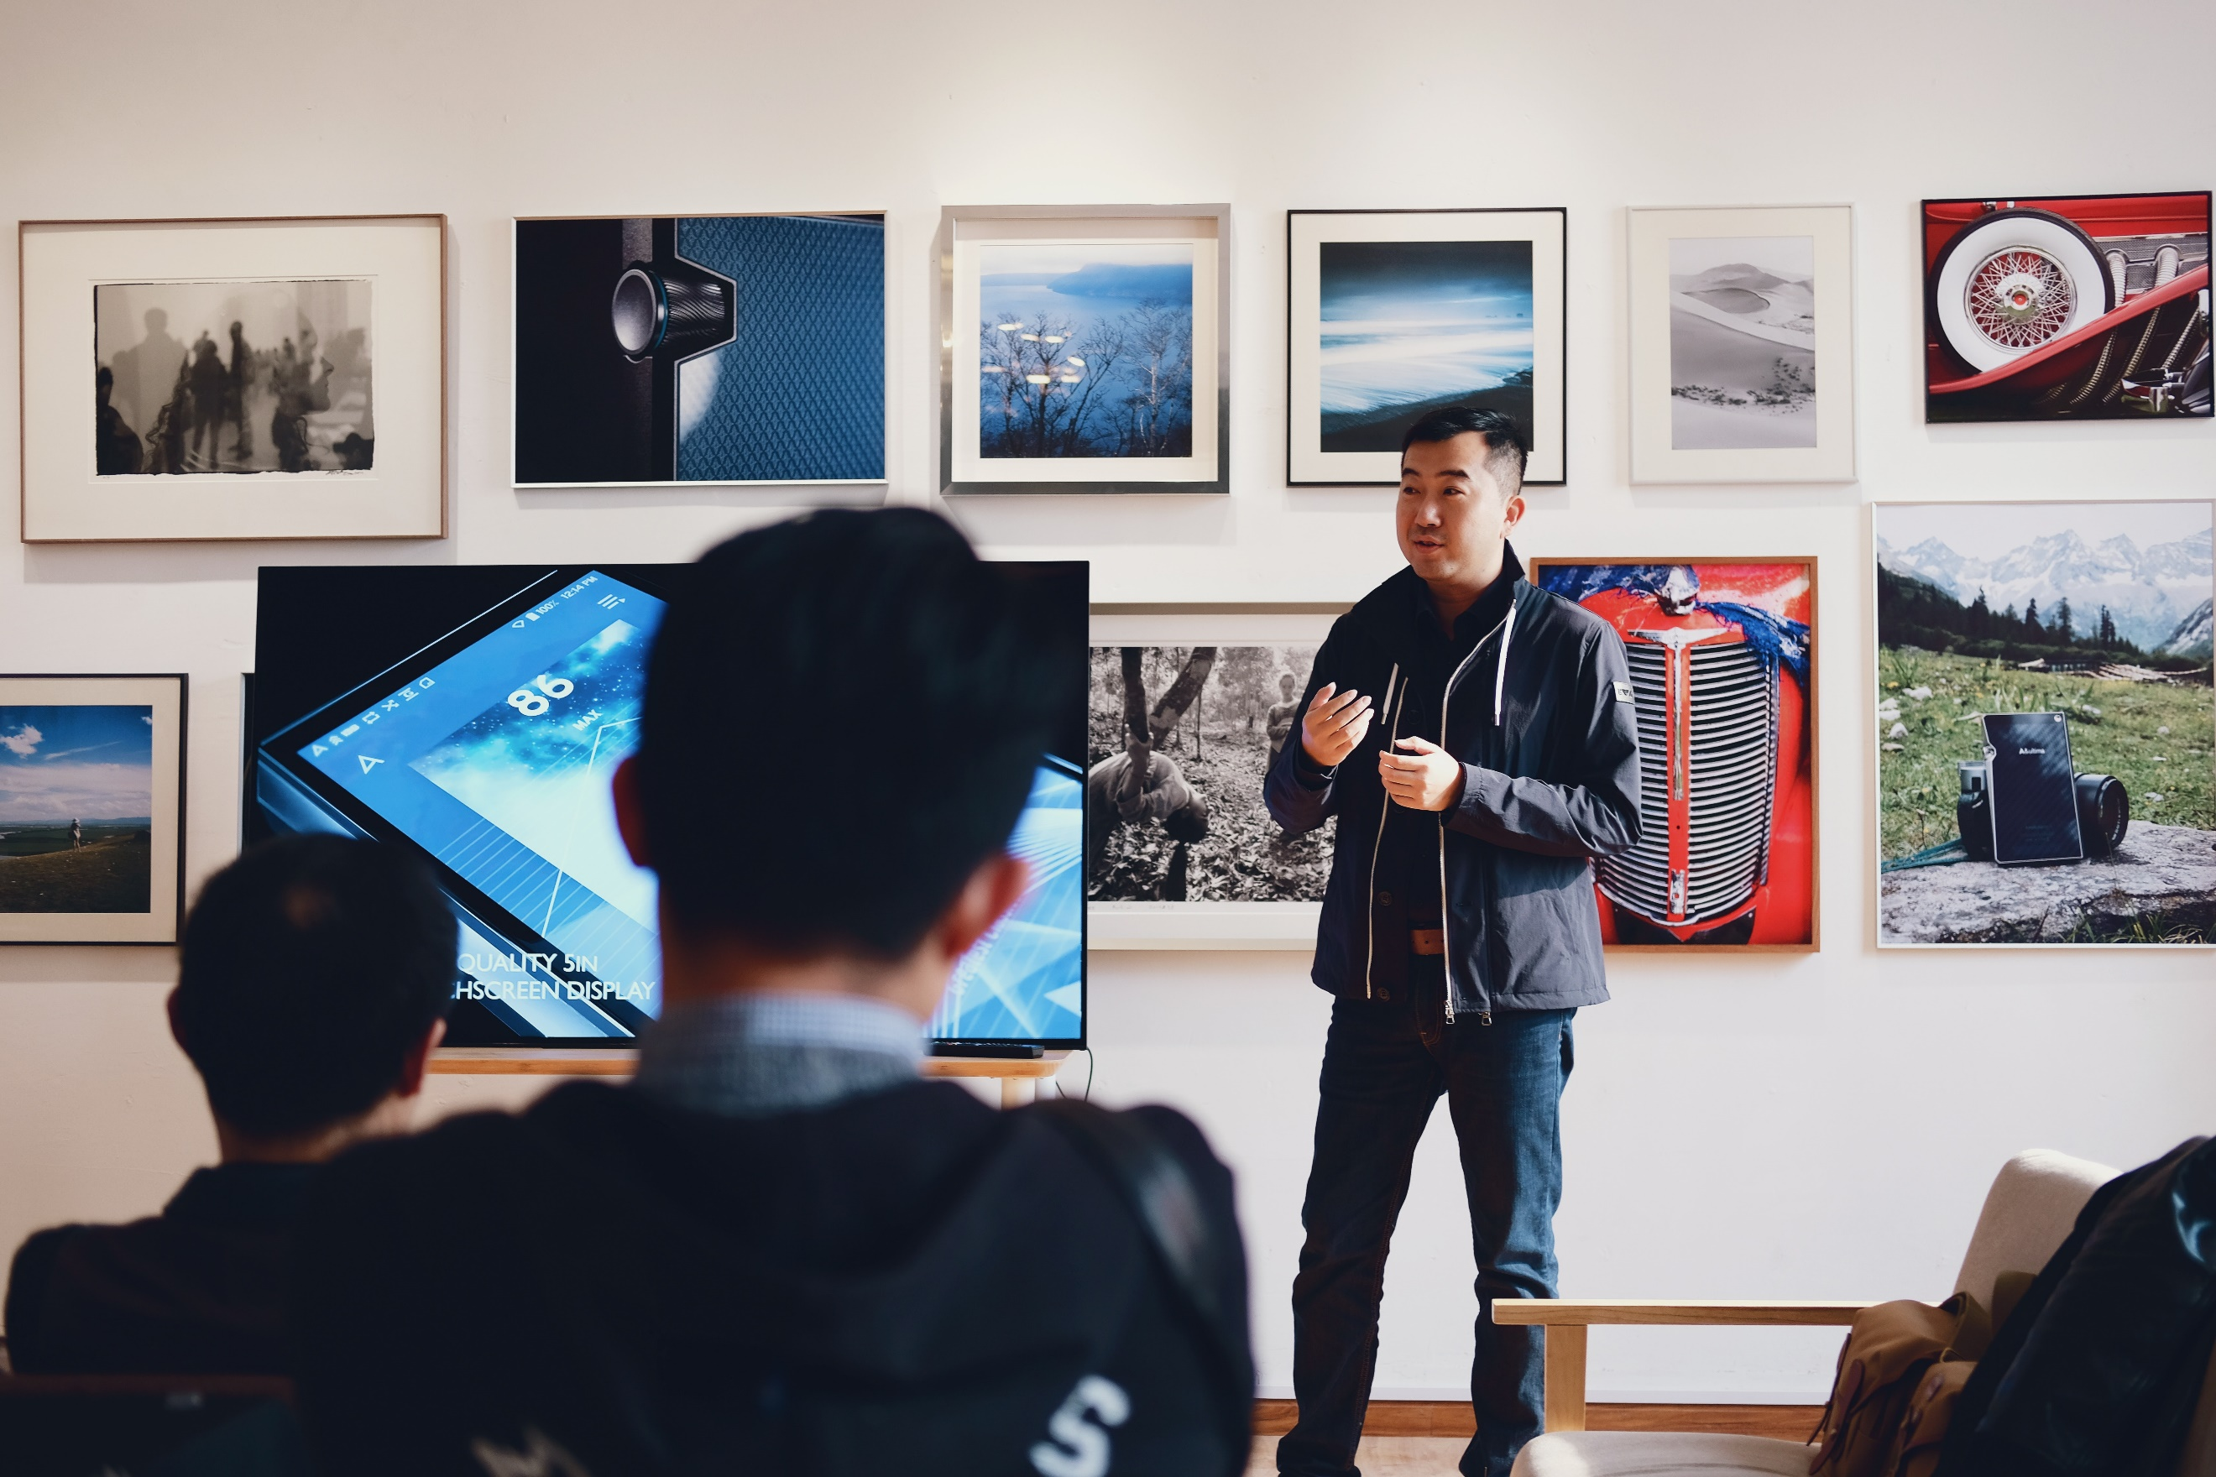 (Zhu, 2018)

1. Molly enters the URL and is directed to the home page of the website.
2. Molly then clicks on the ‘Inside the atom’ button in the top menu.
3. Molly is taken to the ‘Inside the atom’ page, she then scrolls down the page to learn about the different content of this topic.
4. After some skim reading for 10 minutes, Molly clicks on the ‘Back to Top’ link which brings her back to the top of the ‘Inside the atom’ page.
5. Before Molly’s teacher declares that he’s about to starting teaching, Molly clicks on the ‘Chemical Change’ button taking her to that page. Molly skims the ‘Chemical Change’ page to see what other things she could find out from this website.
6. Molly closes the website as her teacher begins to talk. She now has ‘Harry’s Lab’ in the back of her mind as a good research starting point for future assignments.

 (Nguyen, 2018)

# **Visual Organisation**

The key things learnt from the Visual Organisation group discussion:

* For a website to have good visual organisation, the must be the right balance between elements. The positioning of elements is important along with uniformity and consistency across the website.
* There were differences of opinion regarding a particular website’s visual organisation during the discussion. The goes to show that different users will have different opinions of what appeals to them. Hence, it is imperative for user testing and feedback to satisfy the majority of users.

When viewing the lipsum.com website, how much text is too much text on a website was a question raised. In my opinion, there must be enough text on a website such that the user is able to understand to general concept of the website. However, once the user feels that they are being overloaded with information and can’t even remember the first thing they read, then it’s an indication the there’s too much text. It is important to consider white space on a website just to give the user a calm feeling after they’ve digested information. Having well layered-out images around text is also a way to improve visual organisation, as “an image tells 100 words”, so the user is more likely to interact with the website this way. Overall, the lipsum.com website does have too much text and not enough images, which will overload the user’s cognitive load.

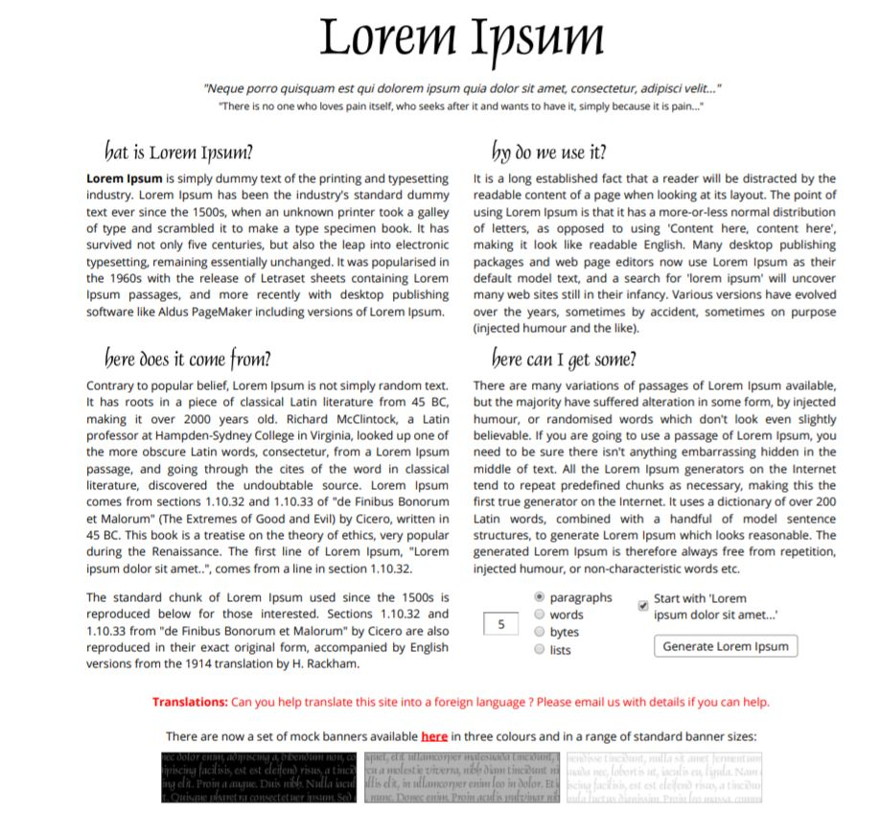

(lipsum.com, 2019)

For my website, it is important that the visual creates a balance between elements with a lasting impact on the user. Not only can the idea of having the right amount of text be taken from the research above, other good design principles such as layout, proximity, alignment and positioning, balance, patterns, etc. should also be taken into consideration.

# **Interactivity & Functionality**

Home page Wireframe:

* The header section itself will be a link to the home page.
* The primary navigation menu will consist of links to content pages. They will be a list of <a> HTML tags styled in CSS to be button-like. Flexbox will be used to for a row arrangement. Furthermore, :hover will be used to change the colour of the ‘button’ on hover.
* The body will have text introducing the website wrapped around an animated image. The image will create fun approach for the user, its animation would be potentially done will advanced CSS or JavaScript.
* The footer will have a ‘Back to Top’ link which is a link to the current page, so the page is reloaded such that the user goes back to the top of the page. There will also be other links in the footer linking to administrative pages such as, ‘Contact Us’, ‘Acknowledgements’, etc. Once again, :hover will be used to change the colour of the link text on mouse hover.

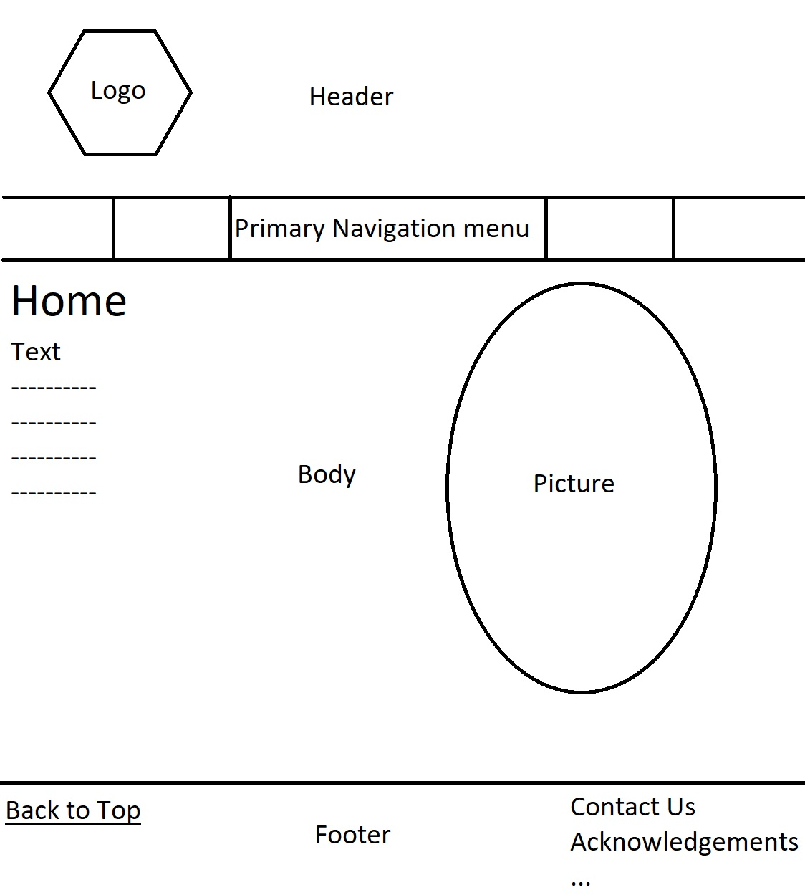

Content pages Wireframe:

* The Header, Primary Navigation menu and Footer interaction functionality will be inherited from the Home page. Furthermore, CSS fixed positioning will be used on the Header, Primary Navigation menu and Footer, so that they continuedly stay at top and bottom respectively of the page when the user scrolls down, this allows the user to easily navigate between pages and go back to the top at point without unnecessary scrolling; this also helps with the flow of the educational content so the similar topics are grouped on the same page. This functionality is available on every page.
* The user is able to scroll down the down the page to access specific content on the current topic page
* A secondary navigation menu will also be present for the user to go straight to their desired content without scrolling. Its functionality will be similar to the primary navigation menu, except the ‘button’ links will be have flex-direction of column. The secondary navigation menu will also be autohide, so when the user hovers on the left side of the page, it will appear and disappear when they hover off. This interaction will be implemented with JavaScript.
* In the primary and secondary navigation menu, which ever page and section the user is currently on, the corresponding ‘button’ in the menu will be a different colour to indicated to the user where they are currently.
* Like the other pages, the body will consist of text wrapped around images. The images with animation interaction done in JavaScript will strive to be content specific to engage the user in their learning and strength the educational content.

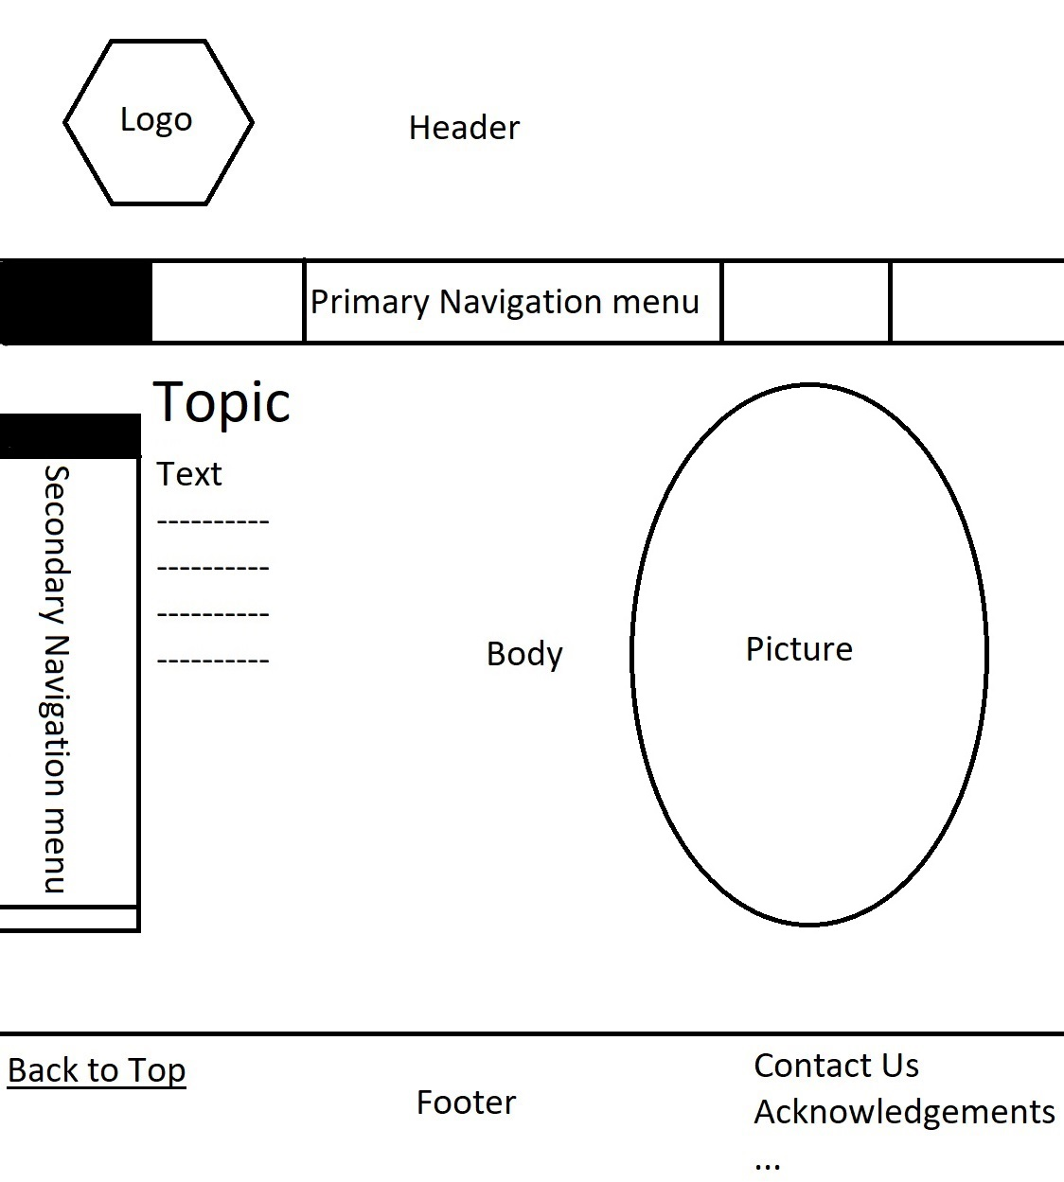

Administrative pages Wireframe:

* The Header, Primary Navigation menu and Footer interaction functionality will be inherited from the Home page.
* In the body, there will be text and images to inform the user about the references in terms of the educational content and images from the book on the Acknowledgements page. Image wrapping around text will be done using floats or Flexbox.
* In terms of the Contact Us page, a contact form will be present in the body, where the user is able to fill out information which can be sent to the website creator. The main structure of the form can be done with HTML with elements such as <form>, <input>, <select>, <button>, etc. and nicely styled in CSS, with submission functionality to be done with JavaScript.

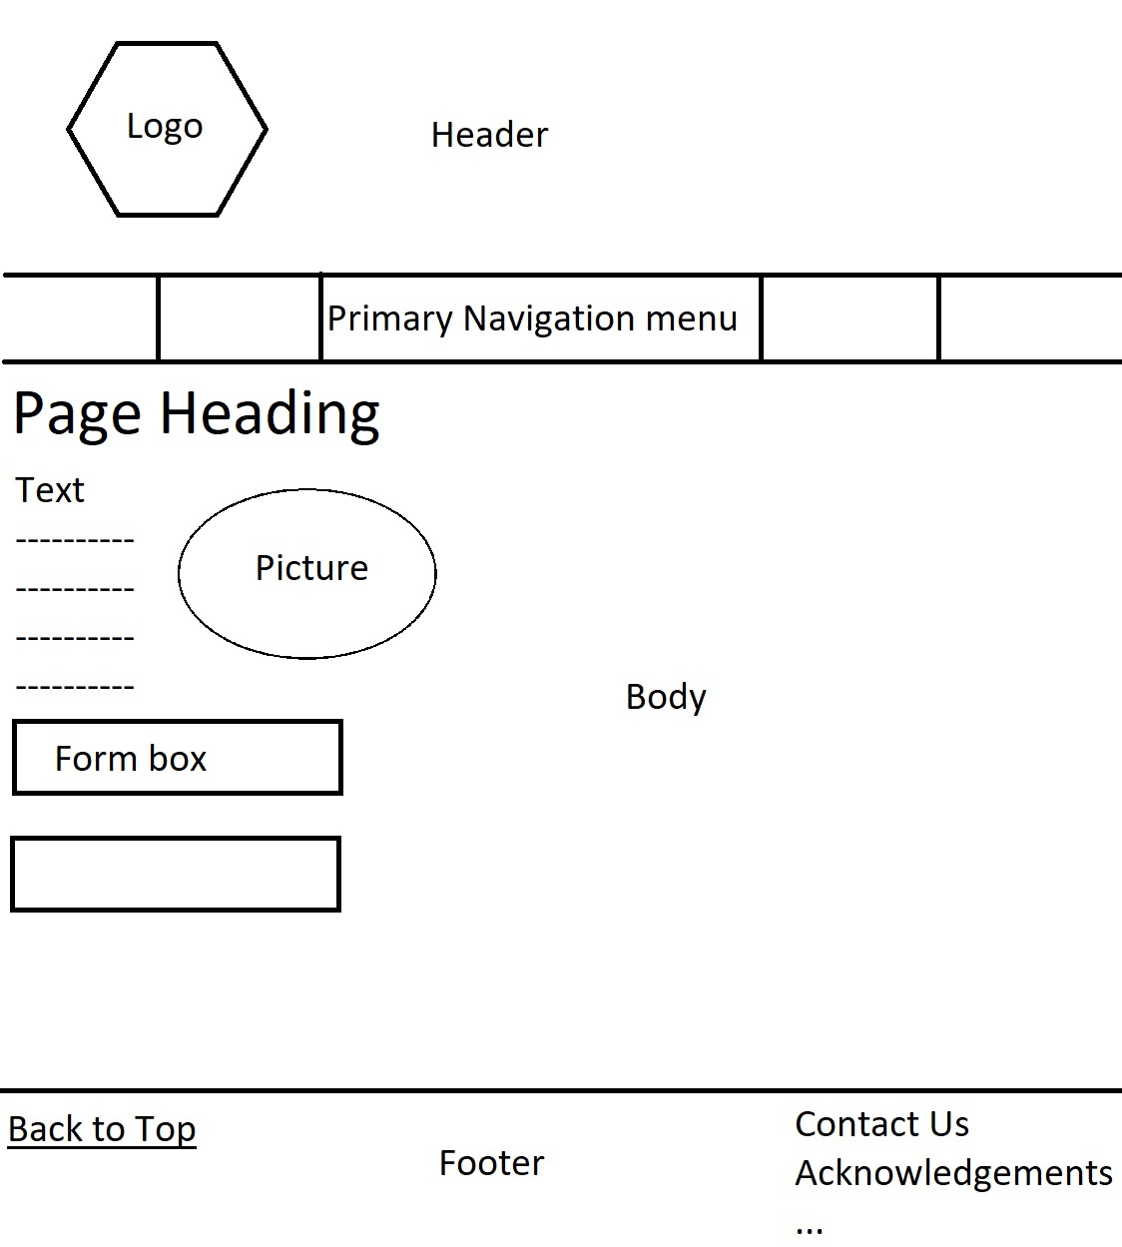

# **Paper Prototyping**

Reflecting on the paper prototyping design activity, it was extremely successful, as it provided helpful feedback from non-biased users on how the visual organisation, navigation and functionality of the website can be improved moving from the paper prototype to the actual implementation.

Photos of my paper prototypes:

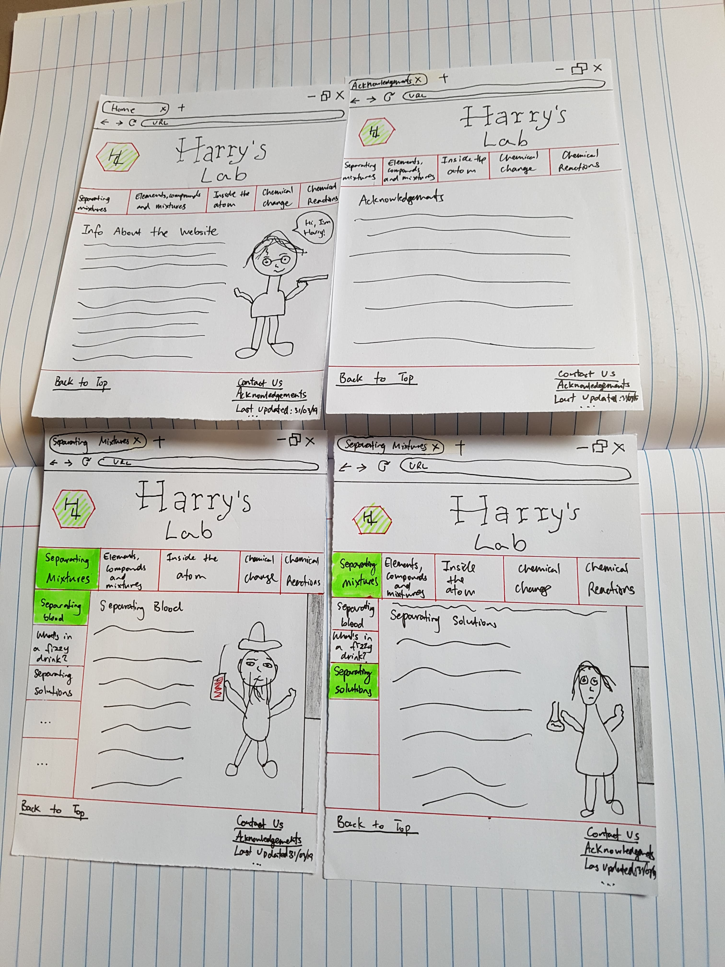

Testing plan developed for paper prototyping:

1. Feedback to get from user:

* Website structure
* Visual organisation (layout of items on prototype)
* Flow and functionality of scrolling up and down a page and going between pages
* Navigation system of prototype website

2. Tasks for user to complete to allow DO (user performing the given tasks), WATCH (observing the user performing the task with minimal help) and ASK (obtain feedback from user by asking them questions about the experience using the paper prototype):

1. Got to ‘separating mixtures’ page
2. Go to ‘separating solutions’ part of ‘separating mixtures’
3. Go back to top of ‘separating mixtures’ page
4. Go to ‘acknowledgements’ page
5. Go back to home page

Photos of running paper prototyping activity:

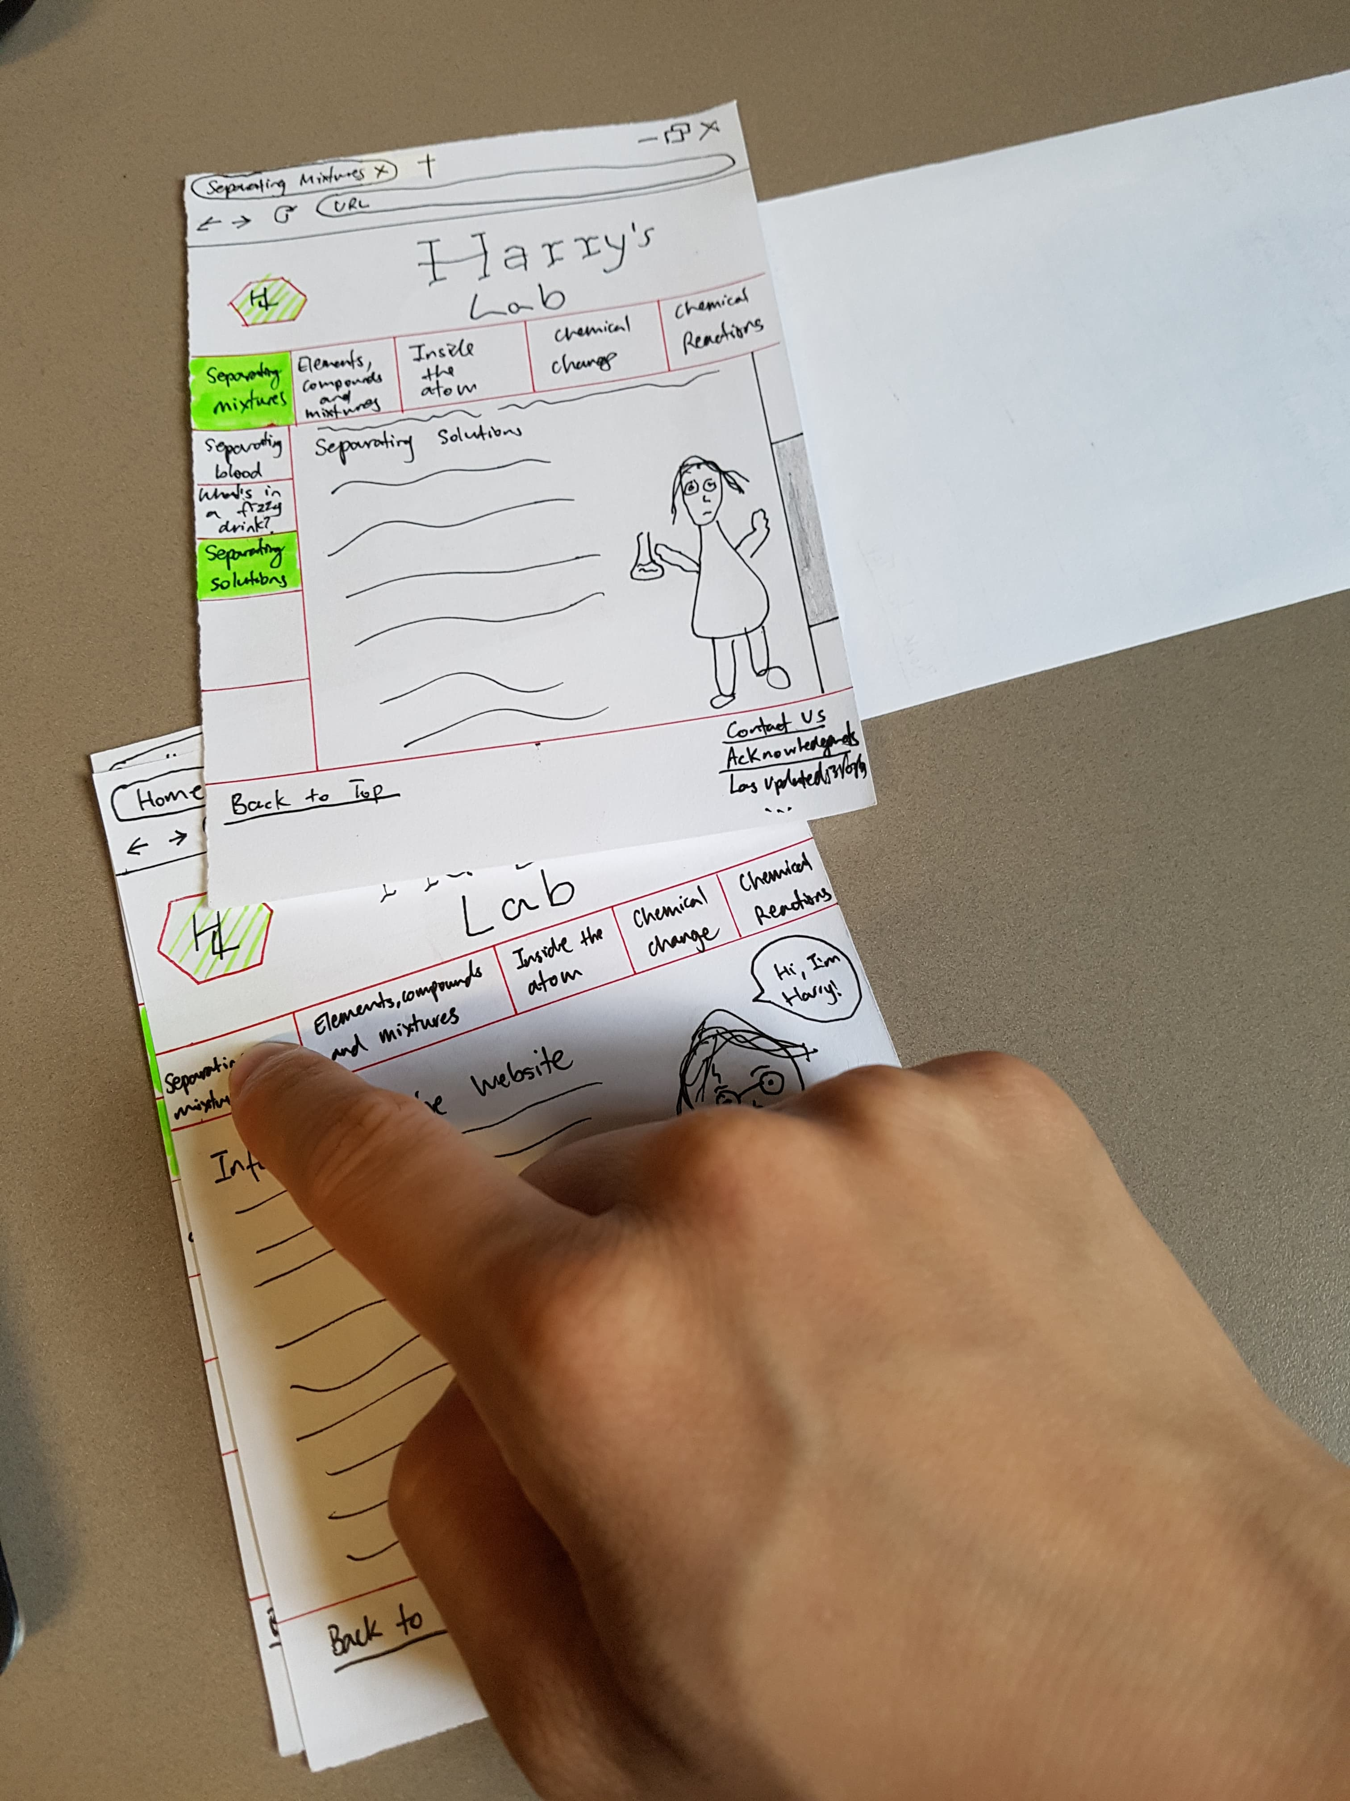

Feedback for paper prototyping activity and implications for the website:

* The paper prototype had a clear navigation system; hence it was easy to go between pages.
  + This means the navigation for my website should be kept like this, with the use of primary, secondary and footer navigation.
* When on a specific section of a page, have the page indication colour of sub-menu different to main menu, so the user can differentiate between the difference.
  + This will be taken into consideration when implementing the website to create a better user experience.
* Think about having a separate contact page with a fill-out contact form (similar to week 5 practical) instead of just using an email link when clicking on ‘Contact Us’. This would make it easier for the user to give feedback on the website.
  + This suggestion will be implemented when creating my website, to satisfy user needs and expectations.
* Consider involving the user a bit more with a name input pop-up on the home page (perhaps related the Harry Potter sorting hat).
  + This feature may be hard to implement such that all pages will reflect action on home page. Will attempt to implement using JavaScript/ jQuery, if unsuccessful, will create an easier alternative interaction.
* When implementing the website, consider docking the main -menu and footer, so the user can easily move between pages or user the ‘back to top’ link when they are in the middle of a page.
  + Will use fix-positioning on header, to make user’s life easy for navigating around website.
* Have the sub-menu auto hide to save space on website.
  + This suggestion can be easily implemented when creating my website, to satisfy user needs and expectations.

**Part B**

Aesthetics

# **Style Guide**

The general aesthetics I’ve chosen for my website is to have a subtly dark themed background with hints of Harry Potter house colours in headers and footers. The Google Serif Font of Delta Respira will be chosen to give a website a Potter theme, with commonly used text fonts such as Times New Roman, Calibri, Aerial used a back-up (if internet was unavailable) for easy readability creating a good typography. The main body text will be surrounded with grey rectangular-edged borders. Font sizes will be kept consistent between headings, paragraphs, etc. Images will be put into appropriate rectangular borders.

The visual aesthetics chosen will be used to engage wit the target audience as much as possible. Being a Harry Potter themed website, it makes sense for the background images be darkish themed and hints of Harry Potter house colours will create an emphasis on the characters from the story and the education content (Chemistry) itself. Overall, it is intended that the website will have a clean look to it, so the user can have a pleasant experience learning whilst on the website.

Researching into good and bad looking websites, it can be seen below that amaysim is an aesthetically pleasing modern website which does an effective job at promoting its product. Amaysim has used bright colours to draw the user’s attention to its mobile plans; however, these colours do not create headaches as the contrasting colours from opposite sides of the colour wheel are put together to create a calming feel. A simple San Serifs font is used to draw the user’s attention to the information on the page without an off-putting experience. Furthermore, good use of text alignment also creates of pleasing user experience.

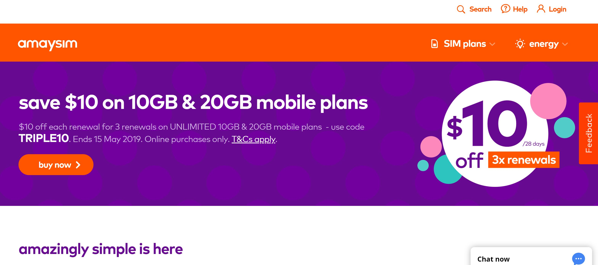

(amaysim, 2019)

The Toast Tech website on the other hand is a website that is not aesthetically pleasing and does a bad job at promoting its products. The dark-red background of the website is not pleasing for the user to look at as it creates a negative impression on the user. The fact that the ‘get Firefox’ button is very small and at the bottom of the page detracts from the product being promoted, as the poor sizing makes it hard to for the user to easily notice.

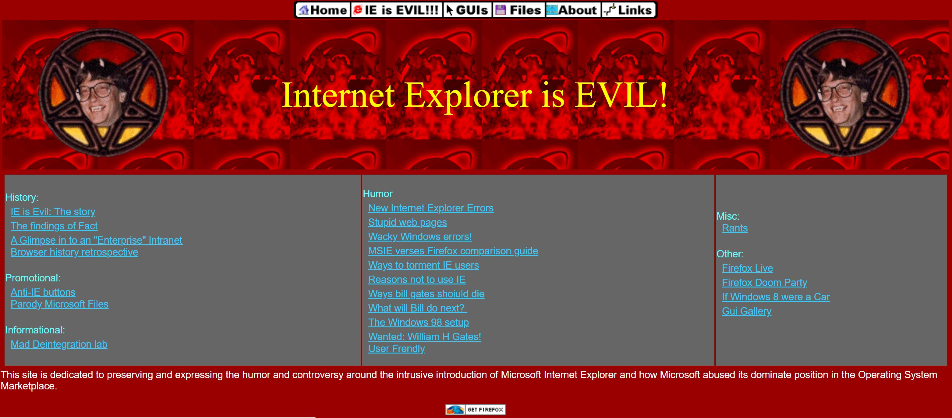

(Toasty Technology, 2019)

This research into websites with good and bad aesthetics should be taken into consideration when making my website. The good features of aesthetics seen should be reflected with bad features to be avoided.

# **Aesthetics User Testing**

The Aesthetics User Testing activity completed was done quite successfully, as it provided an opportunity for a wider scope of feedback on the potential aesthetics of my website. The feedback obtained from this activity was important as it helped shape decisions on the parts of the aesthetic guide that can remain the same or should be changed for the final website implementation.

Screenshots of the mockups used for the activity:

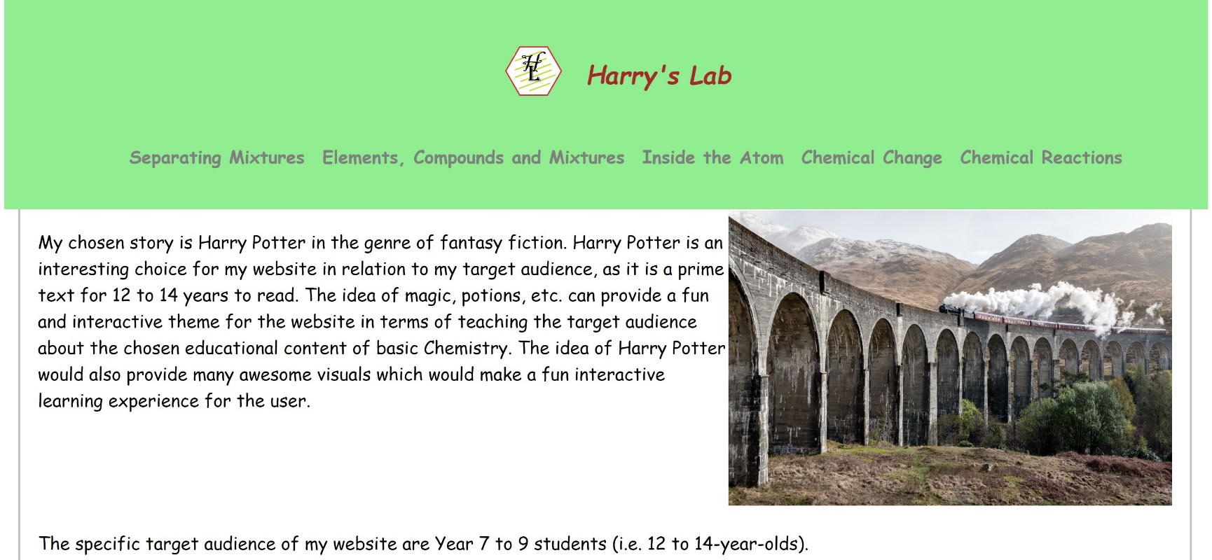

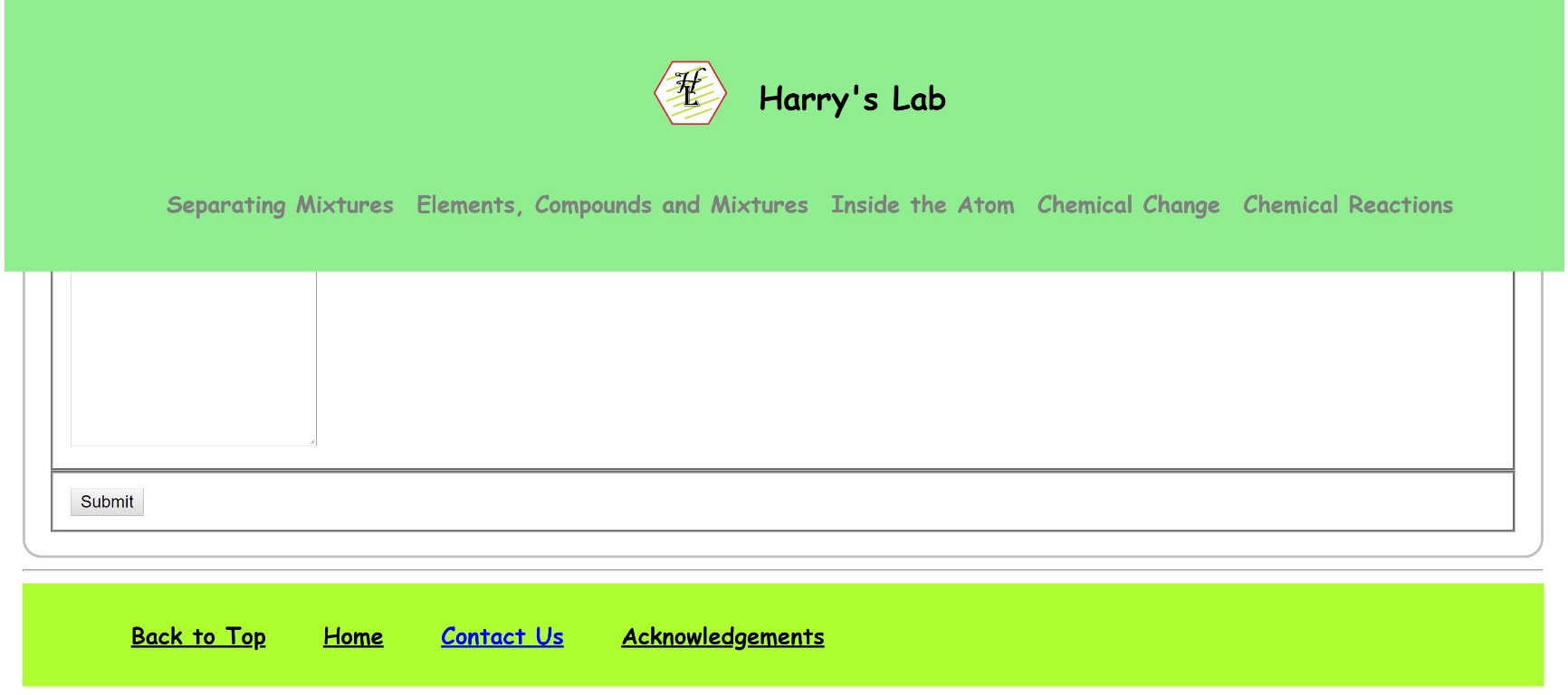

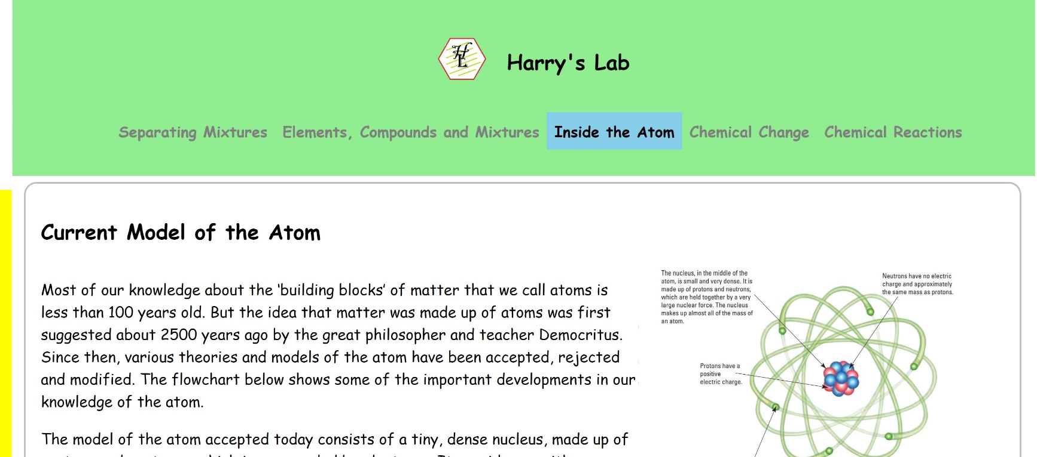

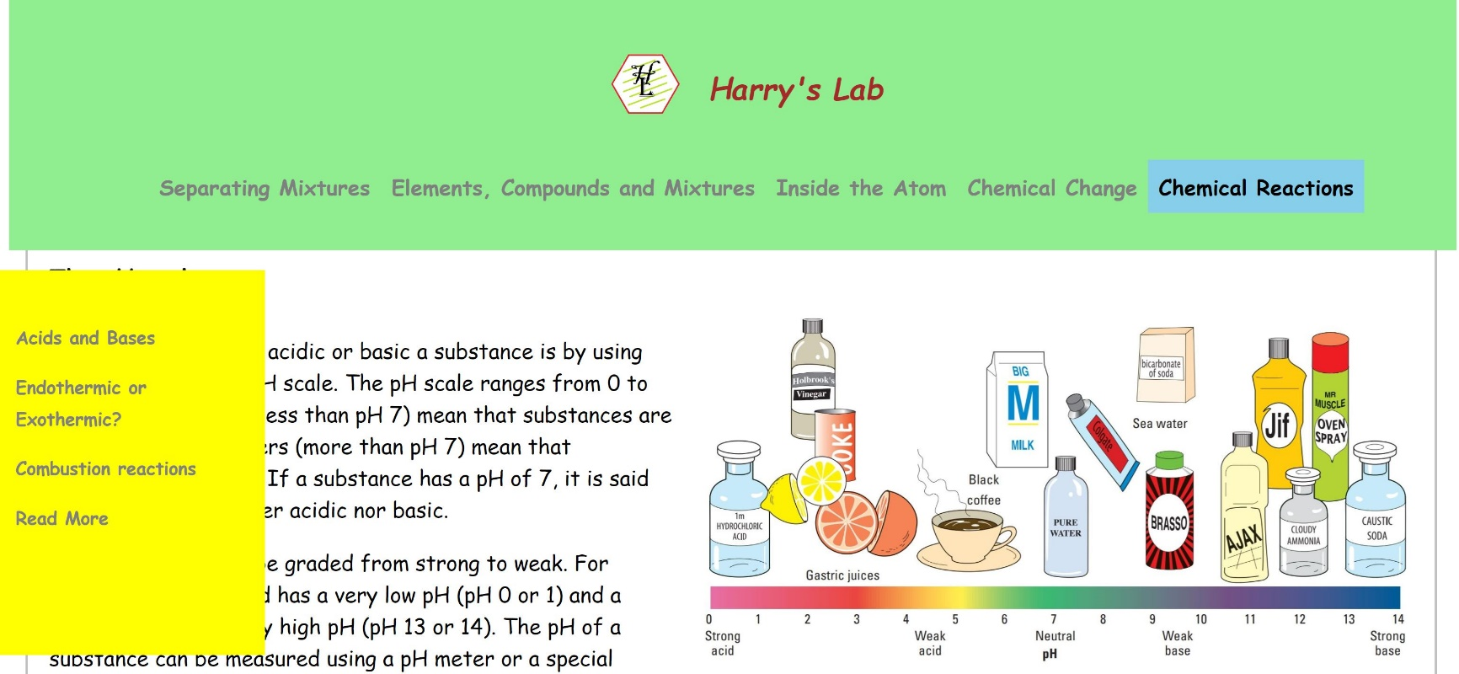

Testing plan developed for the activity:

1. Show user pre-made aesthetic mock-ups.

2. Get the user’s first impression after they’ve viewed the mock-ups, it is important that during this, the user is not provided with descriptions of the website.

3. Describe the mock-ups to the user and clarify any verbal reviews given after the first impressions.

4. Furthermore inform the users about potential aesthetic plans for the website in terms of colour scheme, font, typography, shapes, flow, images, etc.

5. Note down all useful feedback given by the user about the aesthetics of the website.

Photos taken of the activity running:

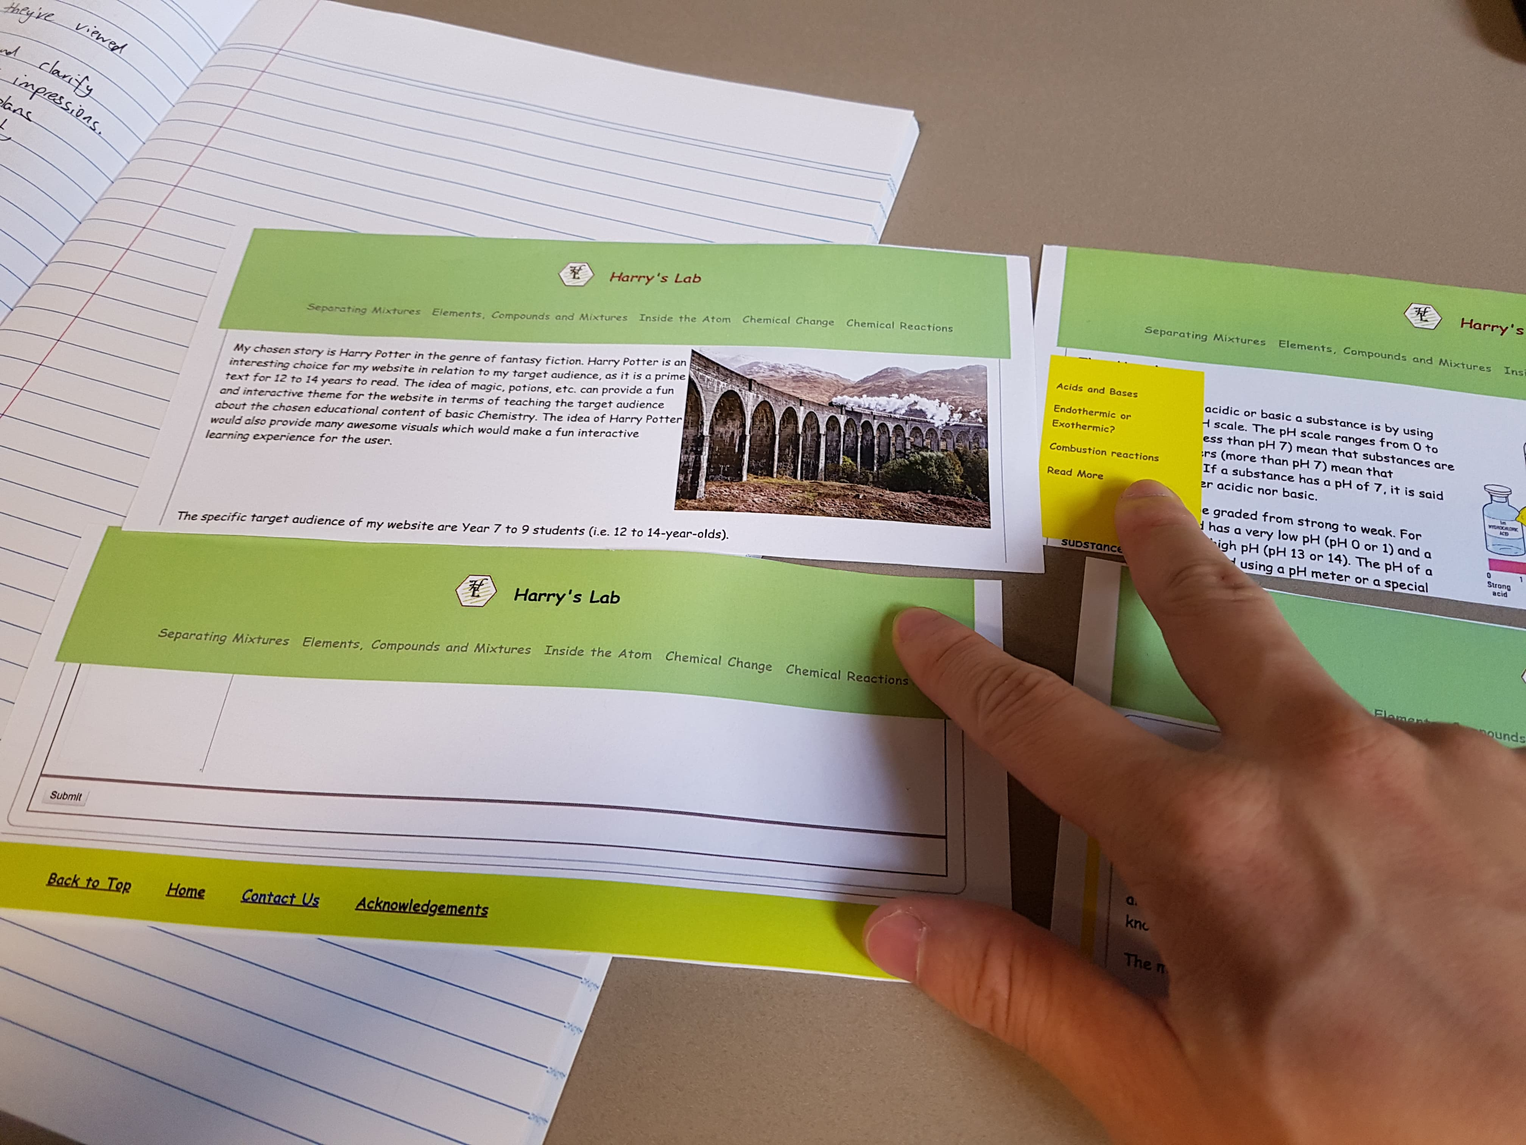

Feedback obtained:

* Current colour scheme on the header, footer and side-menu seems quite plain and makes the website look like it was made in the early 2000s. Also, try to have contrast in the header and footer when choosing colour and background images.
* Although Comic Sans may look nice, it may make the website seem a bit too childish for the target audience of 12 to 14-year-olds. Furthermore, many people are not a fan of Comic Sans, so this font should be changed.
* Currently, as a whole, the website seems too serious. Try to consider ways to weave interactions into each page so it brings out the content more to the user, making the website more aesthetically pleasing.

The feedback obtained helped to inform improvements to be made the aesthetic decisions for my website. Firstly, the header, footer and side-menu will be changed to change to have background images to reflect the story of Harry Potter instead of plain and dull colours. Interaction can be implemented alongside allowing the user to change the background based on what they like. Secondly, a workhorse font such as Times New Roman will be used to make the website look less childish, research into other fonts that best reflect the story whilst drawing attention to the content will also be done. Finally, research will be conducted on looks on modern websites, so the aesthetics of elements of my website can be reflect a modern website.

Website Implementation

# **Accessibility, Graceful Degradation & Progressive Enhancement**

The key things learnt from the group discussion was the importance of the accessibility across all website and the approach of grace degradation versus progressive enhancement when creating a website.

In terms of accessibility, it is important that during the design process the four key guidelines (Perceivable, Operable, Understandable and Robust). from WCAG are considered. Taking the Colour Run website for example, it would be considered to be a website with reasonably good accessibility. Firstly, it is perceivable as good structure is visible with good use of types of text, colour, contrast and spacing. Secondly, in terms of operable, the website is quite function with keyboard only, as basic function like scrolling and tab-enter works perfect allowing simple to all pages within the website. Thirdly, the website is easily understandable with good text positioning, grouping and visual organisation. Finally, the website would be considered to be quite well-written code and considerations for progression enhancement, as the website continues to be functional without JavaScript. Overall, accessibility is important to be considered so the website can be accessed by people of all backgrounds and disabilities. Most modern websites, however, fail to consider this as the developers assume that only people without conditions will use their website. Hence, people with colour-blindness or are vision impaired find it hard to use the website. A simple solution to bridge this gap would be to allow input from people with these conditions during the design and implementation process so websites can be free for all people to access without discrimination.

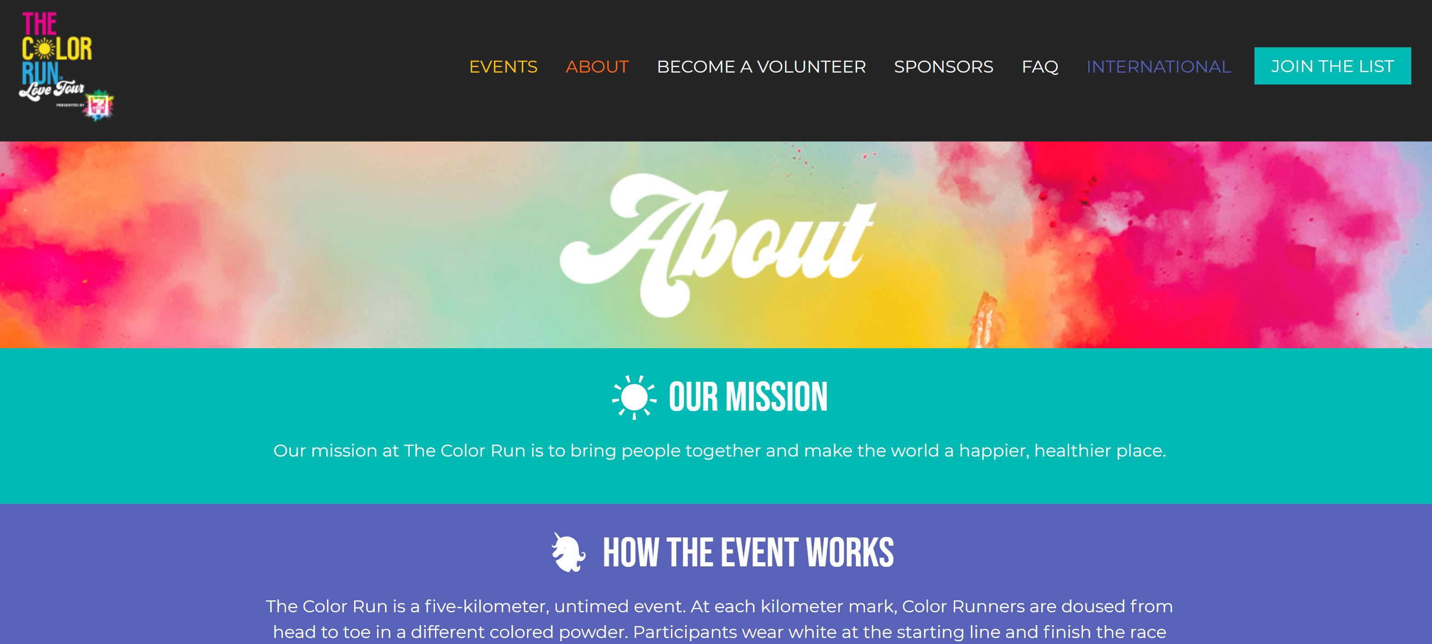

(The Color Run, 2019)

In terms of GD and PE, most websites in the modern age use a graceful degradation approach where they strip away features as they go down the pyramid of older browsers and systems. Seeing, as most people nowadays use modern devices this seems reasonable. However, in instances where the user has JavaScript disabled, commonly used sites like Outlook and YouTube are completely unusable. Hence, progressive enhancement could be considered a better approach, where a website is built up and progressively have more features based on the advancement of the user’s system. This approach is used in the Google search engine, where if JavaScript was disabled, the website still works only not looking as visually attractive. Hence, this ties back to the robustness of accessibility, where it is better to have a working website with less visuals and functionality, than one not working at all.

YouTube with JavaScript disabled:

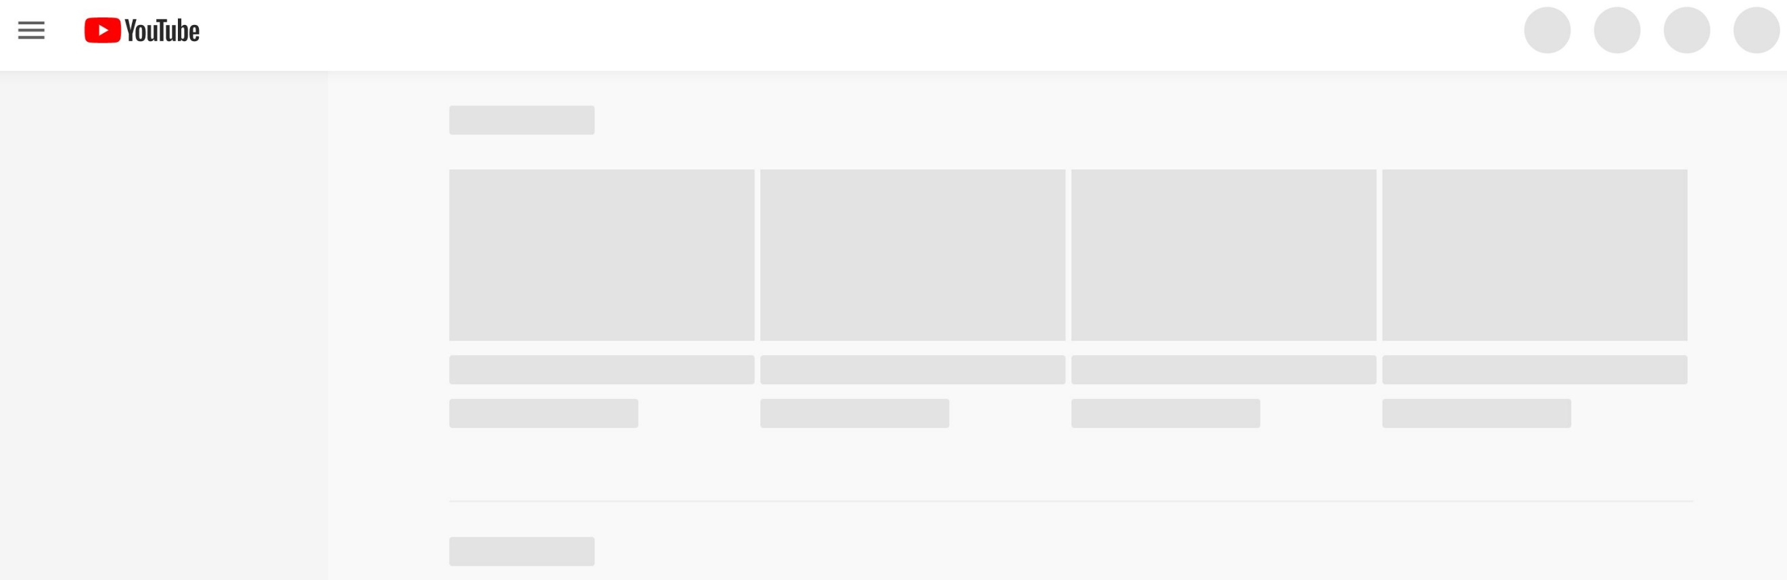

(YouTube, 2019)

Google search with JavaScript disabled:

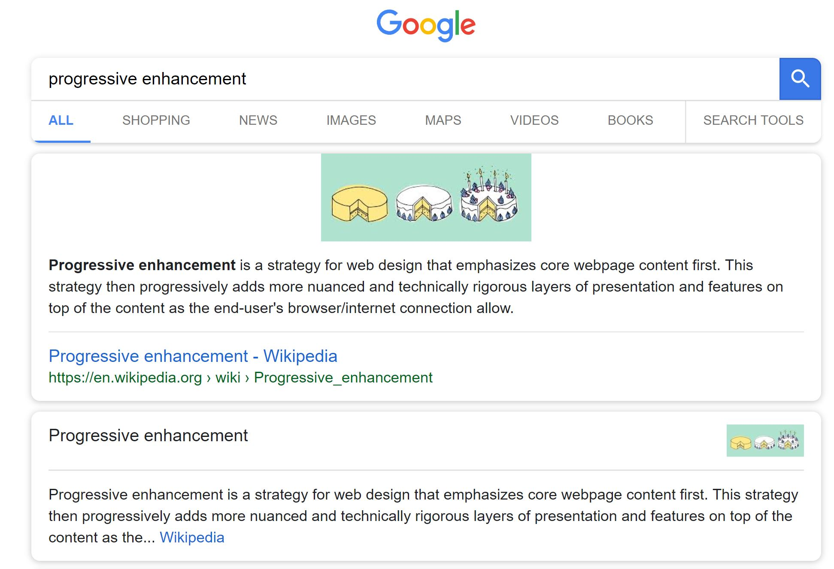

(Google, 2019)

Google search with JavaScript enabled:

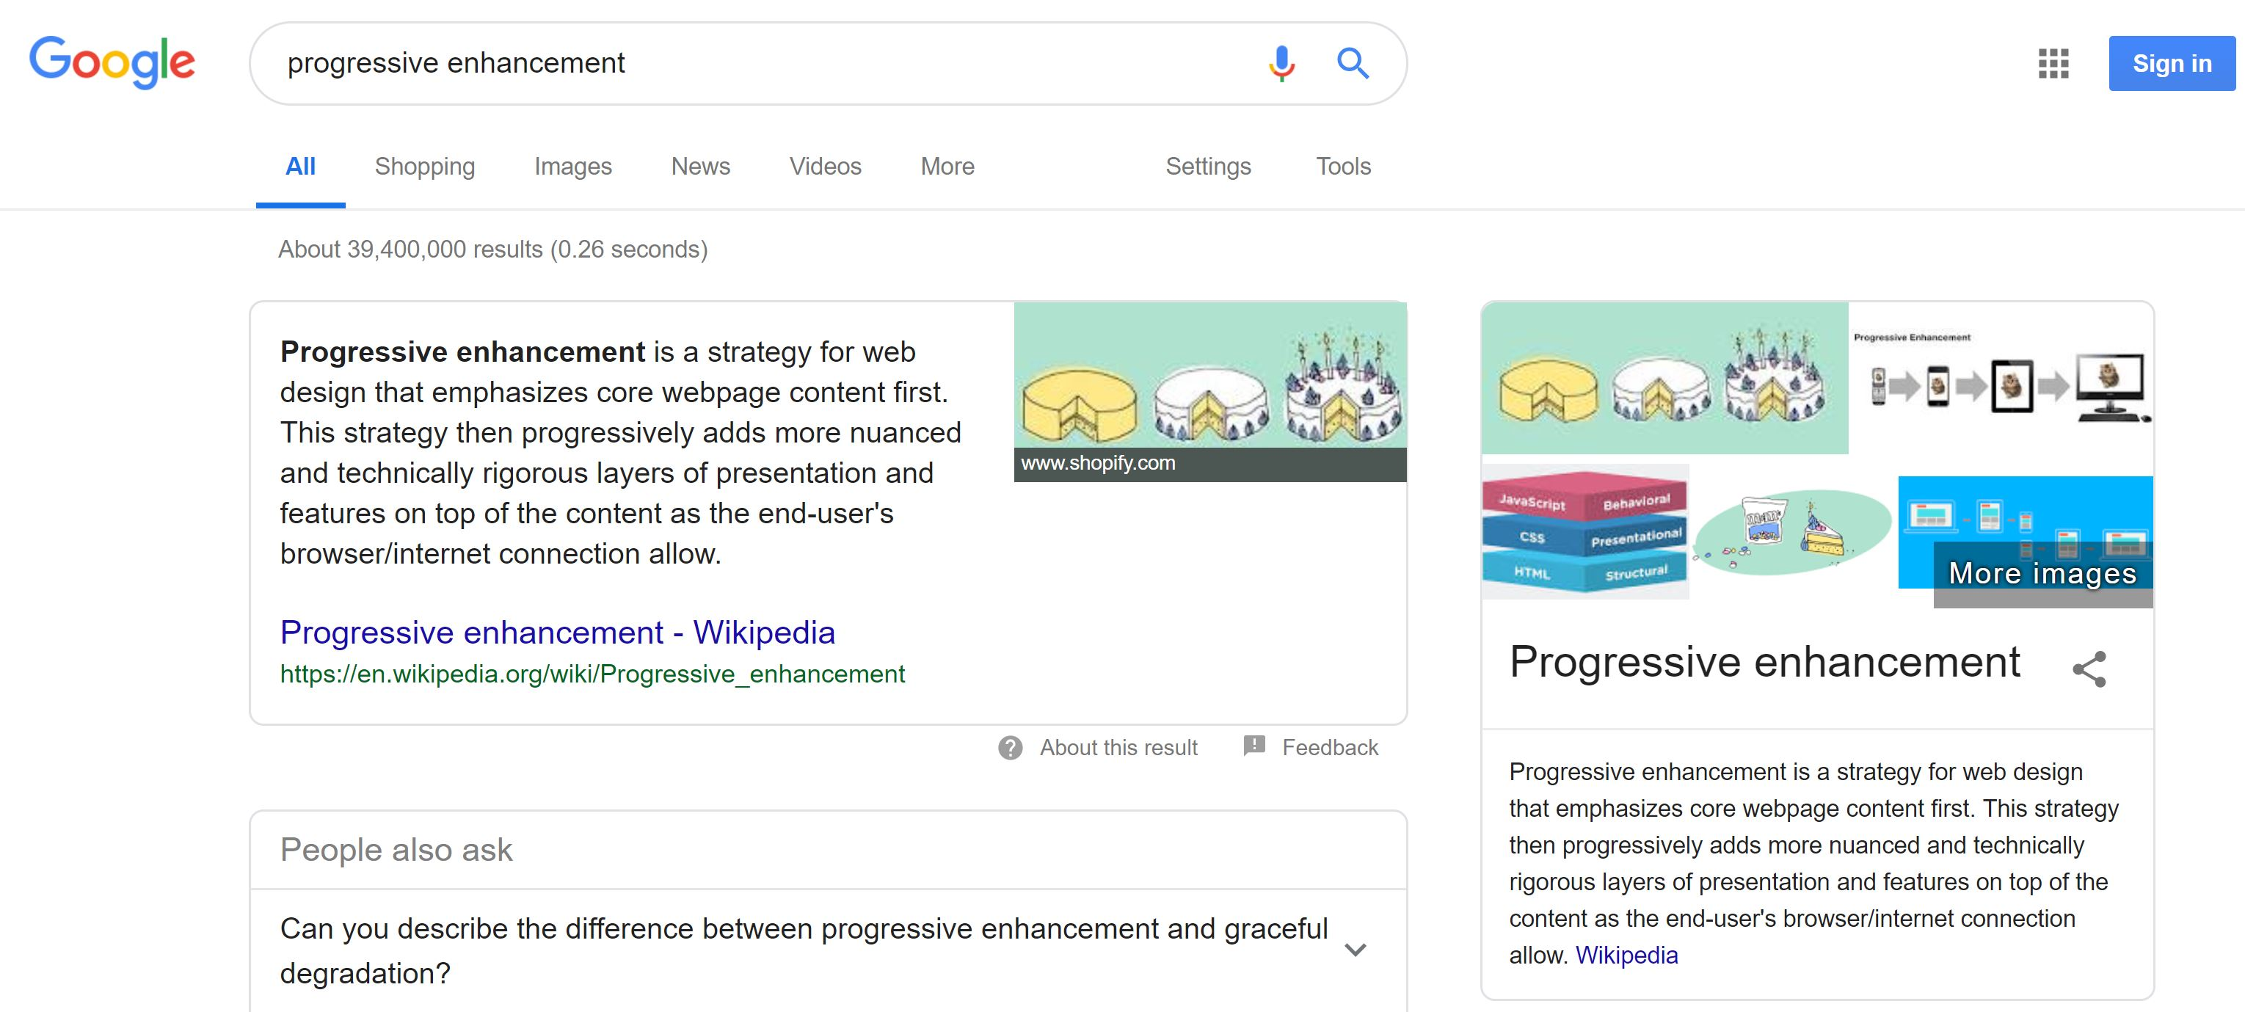

(Google, 2019)

In my website implementation, a strong Progress Enhancement approach will be taken with hints of Graceful Degradation. The website will be designed to have perfect functionality with HTML and CSS only, then built up to include JavaScript as well for interactions unable to be done using CSS. JavaScript interactions such as small quizzes and click animations have been included in each content page on the website to further engage the user’s learning so they can feel like they can actually see the Chemistry happening. Simple unnoticeable interactions, such as shrinking the header on scroll to allow for more scroll space has also been integrated with JavaScript to provide the user with a more seamless experience when using the website. Graceful degradation would be used for the interactions built with JavaScript, where the interactions would not work if JavaScript was unavailable; however, the website would still have about 90% of its functionality, as the website doesn’t rely heavily on the interactions to function. HTML and CSS have been used to a great effect, where backgrounds will have a default colour if the background image doesn’t load for some reason; hence the website would still be usable with purely HTML and CSS. Furthermore, images will have an ‘alt’ to textually inform the user about the image if it wasn’t available.

# **Security & Privacy**

The key things learnt from the Security discussions were the important elements to look for when determining whether a website is secure or not. Firstly, a secure website should have a secure SSL which ensures that the user has a secure and encrypted connection and that any information given to the website stays on the website and won’t be in danger of leaks or nefarious hacks. Secondly, password entries should be obfuscated so that dots appear instead of the user’s password. Thirdly, websites with payments should have a Payment Gateway such as PayPal to ensure that the user’s payment details are secure. Finally, a secure website should have good design to make it seem trustworthy to the user; these design elements could include contact details, relevant images/ text, correct use of spelling and grammar, up-to-date information, etc.

Since my website isn’t actually getting published online, it would be difficult to implement security measures such as an SSL and payment gateway. However, it will still follow the good design principles listed above to show the user visually that my website is secure.

The Hogwarts Diary is an example of an online store website with average perceivable website security and trustworthiness.

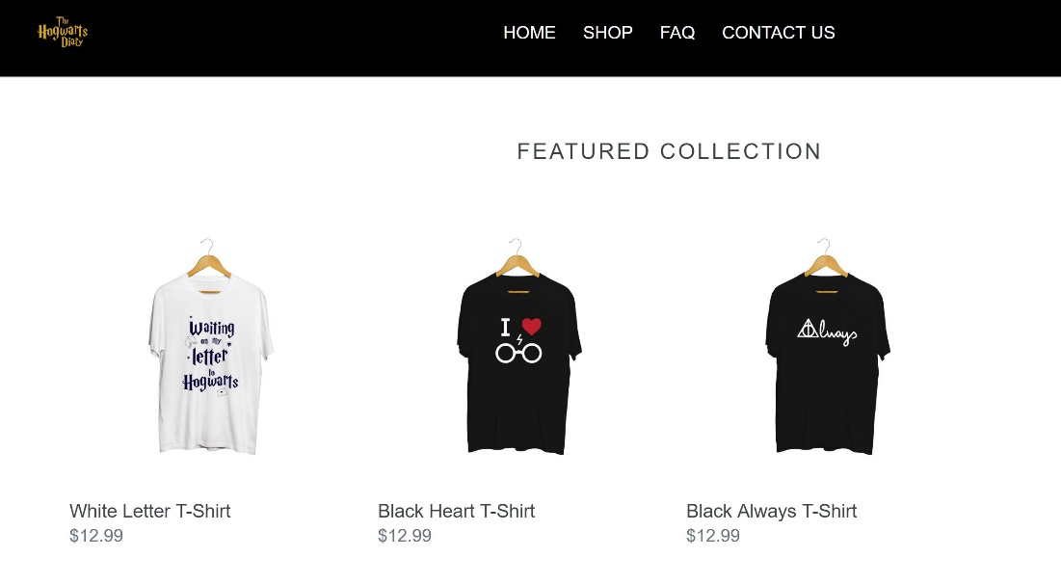

(The Hogwarts Diary, 2019)

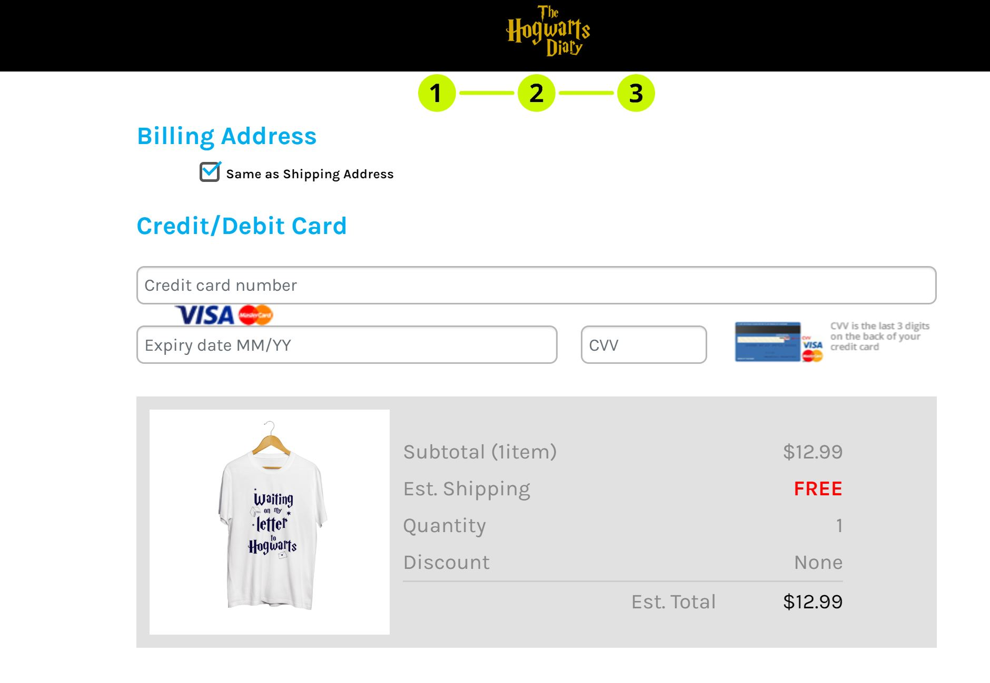

(The Hogwarts Diary, 2019)

Areas of success in perceivable and functional website security and trustworthiness:

* Website has a secure SSL (Secure Sockets Layer) located left of the URL in the form of a padlock icon.
* Apparently up-to-date information with 2019 listed in the footer.
* Website has a decent Navigation System, so the user can easily go between different pages.
* Has contact details, so user feels somewhat secure about hunting the seller should any issues arise.

Areas of failure in perceivable and functional website security and trustworthiness:

* Only three products on website and no customer reviews about products. Makes it seem like some random person made this website.
* No payment gateway like PayPal to ensure that payments are secure.
* Visual Organisation is poor in terms of using good text and image alignment.

The key thing learnt from the Privacy discussions was the importance of preserving a user’s private information when they are on a website. The simplest form of privacy for a website is that it uses HTTPS instead of a HTTP, so user information remains private.

Web tracking occurs on most websites, where user activity and analytics such as, clicked links, entered information, etc. is tracked. Cookies are often used with web tracking on websites for personalisation, arranging content to match a user’s interests. First party cookies can be useful, as it’s used to remember that a user is logged in and suggest commonly entered information to make the user’s life easier. However, third party cookies can get creepy, where the tracked user activity is used to tailor adverting based on the returning user’s history.

Most websites which deal with user information will have a specific section outlining its privacy policy. Majority of the time, the privacy policy is not very human-readable as it is just chunks of text. TunnelBear is an example of a website with a good privacy policy, as it takes a more human readable approach to their privacy policy. This would mean clear headings with tables and images explaining what each thing means. Having a privacy with lots of text in small font can often lead to users clicking on the next thing on the website without reading the finer details. This could cause privacy breaches if the user agreed to their information being distributed without knowing.

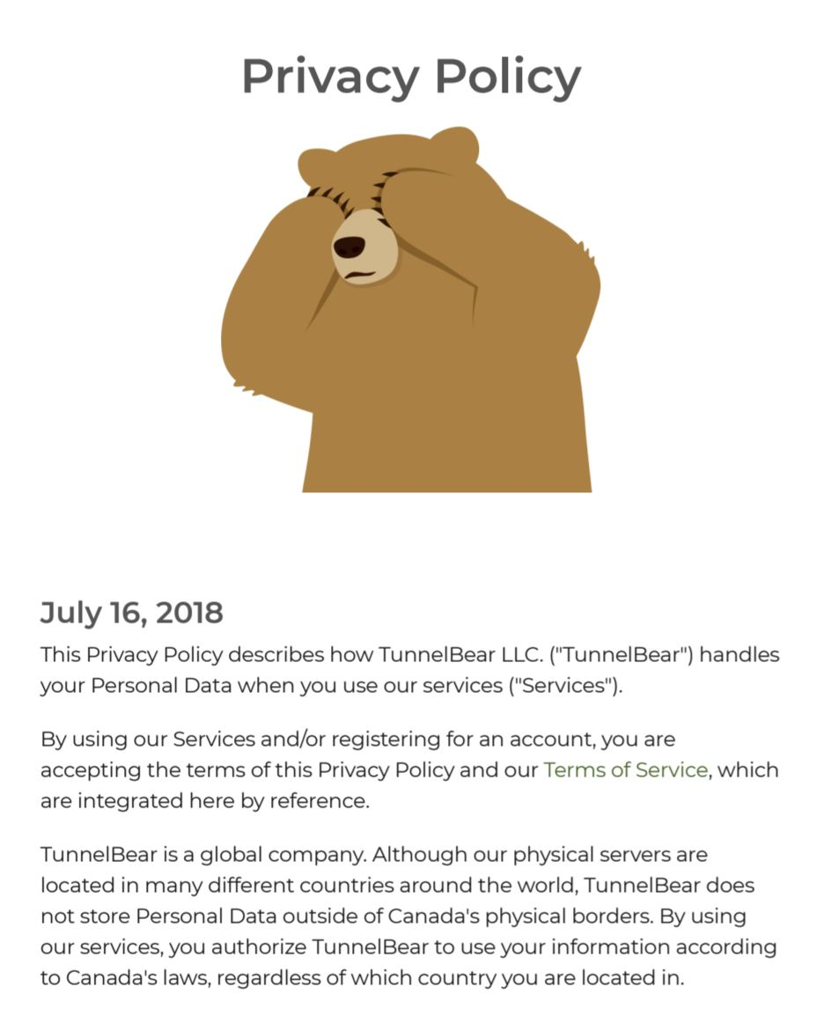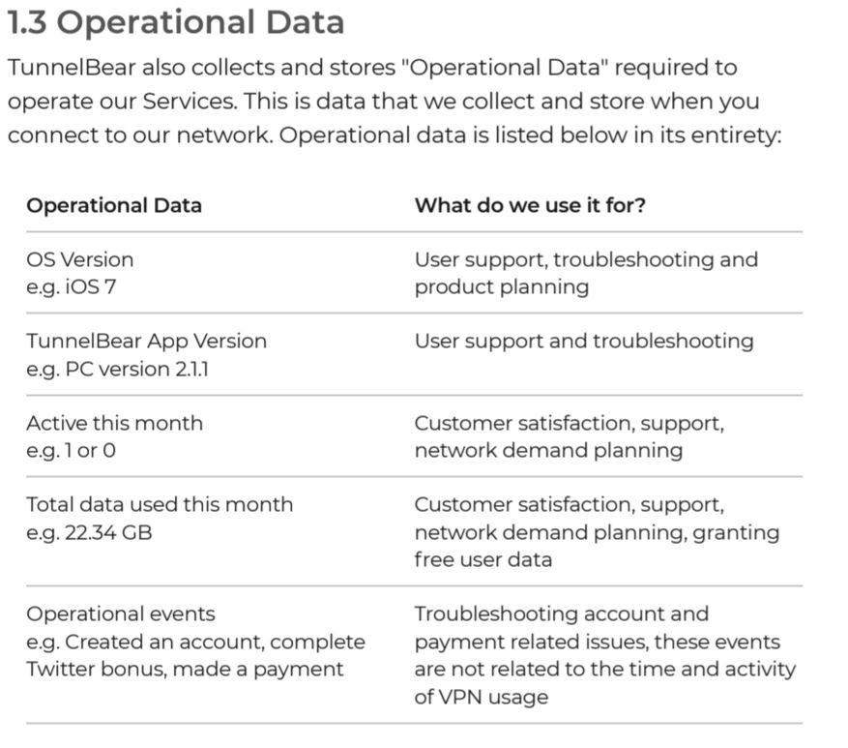

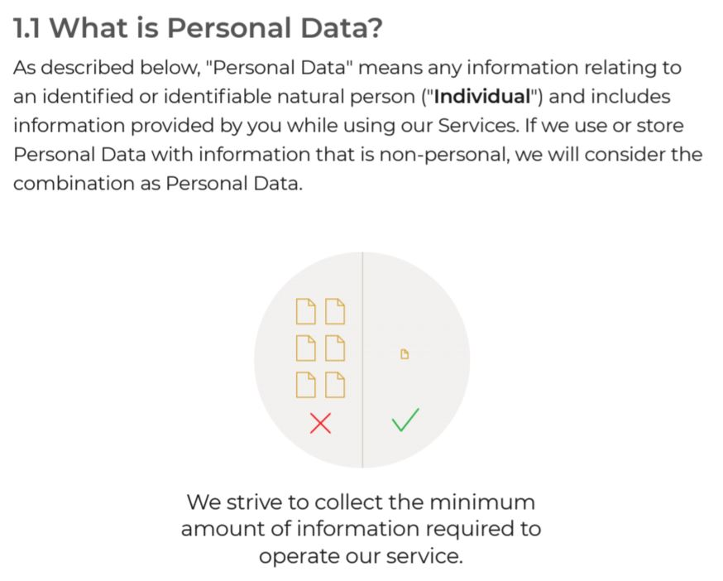

(TunnelBear, 2019)

In terms of privacy on my website, I won’t be having a dedicated page for a privacy policy, as my website won’t be tracking user movements and obtaining large arounds of personal information. However, on the ‘Contact Us’ page, where the user is prompted to enter some of their personal details (JavaScript form validation is used here), there will be a short paragraph at the top of the page, indicating to the user that their information will be kept safe and private.

# **Hi-Fi User Testing**

The Hi-Fi User Testing activity completed was quite successful as it allowed for meaningful user evaluations from non-biased external sources. The feedback obtained from this activity was helpful, as it raised some important points for consideration before submitting the final product of my website.

Testing plan developed for the activity:

1. Briefly describe to use the background of my website in terms of story and educational content.

2. Get user to complete a few tasks to test general functionality of my website. Each task will have a DO (complete task), WATCH (observe user’s actions) and ASK (obtain user feedback).

1. Do checking question on Home page.
2. Go to ‘Elements, Compounds and Mixtures’ page and play the interactive quiz.
3. Go to ‘Chemical change’ page and do the interactive knowledge check.
4. Fill in the contact form in the ‘Contact Us’ page.
5. Browse around every page on the website trying to explore all functionality of the website.

3. After the user completes the set tasks, record their general feedback of the website. Also, ask the user prompting questions about functionality and aesthetics.

4. User feedback will be taken into consideration for finalising the website for submission such that, changes and additions are made to satisfy user expectations.

Photos of the activity running:

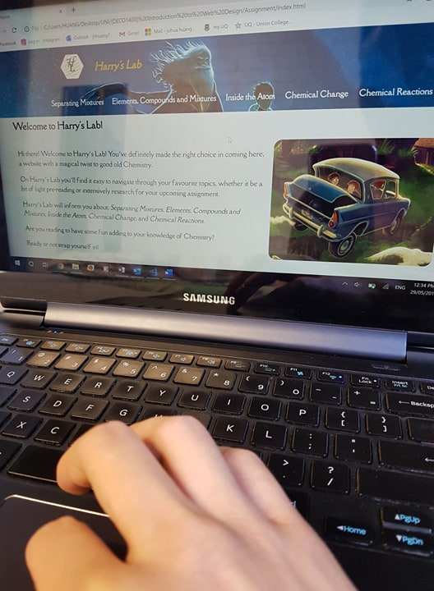

Feedback obtained how it informed the final product:

* Make sure primary navigation on hover doesn’t make text goo off screen.
  + This can be easily fixed by changing the on-hover font size in CSS.
* Links on the body of the home page aren’t clear that they’re links.
  + Along with italics, can make text bold as well.
* In content pages, it isn’t clear to first-time users that there is a side-menu.
  + Can be fixed by adding an arrow or text pointing to the side-menu, informing the user of its existence.
* Try to implement more meaningful JavaScript interactions.
  + Will try to have a piece of interaction implemented on every content page. Can be as simple as creating image animations on click to further engage the user in their learning.
* There is some white/ wasted space on some of the content pages, when the text height overtakes the image height.
  + Can be fixed by adjusting the positioning of elements within the page.

Conclusion

This Design Report has detailed all of the design process behind producing my website. It has covered various design activities and research topics which has contributed to making my website a good one.

In short, my website has been successful in responding to the brief as it takes the classic story of Harry Potter with the educational content of basic high school Chemistry to produce a fun and interactive website for 12 to 14-year-old students. My website has used semantically correct HTML, CSS, JavaScript and jQuery to be produced at a high quality.

# **Course Reflection**

Going into this course, my learning strategy was to essentially start early on all task to allow ample time for feedback. I followed this strategy throughout the course and was able to produce the outcome I wanted. So, for future design courses, I will continue to adopt this learning strategy to ensure that I continue my success.

If I had to chance to restart, there wouldn’t be too many things I’d change as I believe I have succeeded at doing well in this course. However, the one thing I would do differently, would be to do more practice at website implementation activities after practicals. This would allow me to be more familiar when writing HTML, CSS, JavaScript and jQuery, hence decreasing the reliance on Googling and asking tutors on how to do certain things and overall improve me as a programmer.

References

amaysim. (2019). *save $10 on 10GB & 20GB mobile plans*. Retrieved from https://www.amaysim.com.au/

arngren.net. (2004). *www.arngren.net*. Retrieved from http://arngren.net/

freestocks.org. (2018, December 29). *Bokeh Photography of Woman in Brown Parka Jacket*. Retrieved from https://www.pexels.com/photo/beautiful-christmas-fashion-female-284011/

Google. (2019). *progressive enhancement*. Retrieved from https://www.google.com/search?q=progressive+enhancement&gbv=2&sei=0UnSXPuSCs32rQHAj6TYCw

Highschool Australia. (2019). *THE AUSTRALIAN EDUCATION SYSTEM*. Retrieved from https://www.high-school-australia.com/australian-education-system/

IKEA. (2019). *Join IKEA Family and get a $10 Reward*. Retrieved from https://www.ikea.com/au/en/

lipsum.com. (2019). *Lorem Ipsum*. Retrieved from https://www.lipsum.com/

Mars, B. (2019, April 4). *Man Sitting In Front Of Computer Monitor*. Retrieved from https://www.pexels.com/photo/man-sitting-in-front-of-computer-monitor-2099483/

Moose Photos. (2018, April 23). *Men's Black Leather Zip-up Jacket*. Retrieved from https://www.pexels.com/photo/men-s-black-leather-zip-up-jacket-1036643/

Nguyen, N. (2018, November 24). *Person Writing While Using Phone*. Retrieved from https://www.pexels.com/photo/adult-blur-business-close-up-239548/

Palai, G. (2007, July 13). *Harry Potter Photos*. Retrieved from https://www.pexels.com/photo/train-with-smoke-507410/

The Color Run. (2019). *Love Tour*. Retrieved from https://thecolorrun.com.au/#events

The Hogwarts Diary. (2019). *FEATURED COLLECTION*. Retrieved from https://thehogwartsdiary.com/shop/index.php?pid=2

Toasty Technology. (2019). *Internet Explorer is EVIL!* Retrieved from http://toastytech.com/evil/

TunnelBear. (2019). *Privacy Policy*. Retrieved from https://www.tunnelbear.com/privacy-policy

Wiley, J. (2018). *Science Quest 7-10 Australian Curriculum Second Editions: Page Proofs*. Retrieved from http://www.jaconline.com.au/page/news/163-science-quest-7-10-australian-curriculum-second-editions-page-proofs

YouTube. (2019). *YouTube*. Retrieved from https://www.youtube.com/?gl=AU&hl=en-GB

Zhu, H. (2018, December 4). *Man Beside Flat Screen Television With Photos Background*. Retrieved from https://www.pexels.com/photo/man-beside-flat-screen-television-with-photos-background-716276/